

|  |  |
| --- | --- |
| Department of Aquatic Resources |  |
| **The effect of temperature on life history traits of perch (*Perca fluviatilis*) and its implications for population age- and size structure.**    Malin Karlsson | |
|  | |
| Independent project • 60 credits  Master studies in Biology  Öregrund 2020 | |

|  |
| --- |
| The effect of temperature on life history traits of perch (*Perca fluviatilis*) and its implications for population age- and size structure.  Malin Karlsson |
| Supervisor: Max Lindmark, Swedish University of Agricultural Sciences, Department of Aquatic Resources  Assistant supervisor: Anna Gårdmark, Swedish University of Agricultural Sciences, Department of Aquatic Resources  Examiner: Karin Limburg, SUNY College of Environmental Science and Forestry. Visiting Professor at Swedish University of Agricultural Sciences, Department of Aquatic Resources |
| Credits: 60 credits  Level: A2E  Course title: Master thesis in Biology  Course code: EX0778  Course coordinating department: Department of Aquatic Resources  Place of publication: Öregrund, Sweden  Year of publication: 2020  Online publication: <https://stud.epsilon.slu.se>  Keywords: Specific growth, von Bertalanffy growth model, Mortality, Size structure, Size-spectra, Fish, Perch, Perca fluviatilis, Climate change |
|  |
| Swedish University of Agricultural Sciences Faculty of Natural Resources and Agricultural Sciences (NJ)  Department of Aquatic Resources  SLU Aqua |

# Abstract

The effects of increasing water temperature on key life history traits of fish (e.g. growth rate and maximum body size) have in recent years received considerable attention, but evidence remains inconclusive. Warmer water will increase the metabolic rate, which in turn can increase body growth, if this higher energy demand can be met by increased food intake. Increased metabolic rate is also predicted to increase mortality rates of fish, even though the literature on this is less conclusive. When it comes to effects of temperature on maximum body size, opinions vary. Studies have found or predicted negative effects of temperature on maximum body size while a recent study on a non-commercially exploited fish showed no clear signs of smaller adult body size. These diverging observations warrant more studies quantifying fish responses to warming. Both temperature and fishing are expected to induce changes in growth rate and maximum body size, and the interactions between, and relative importance of, these factors are difficult to quantify in commercially fished populations. Therefore, it is important to quantify general patterns of temperature responses on non-commercial species in natural environments. Fish growth and mortality are of high ecological importance since they determine the size and age structure within a population, which affects resilience capacity of a fish stock. Here, I ask how growth rate, asymptotic size and mortality may change in response to increased temperature, and what the implications for populations size-spectra and mean size will be. To this end, I collate and analyse fish life history data (1987-2003) of perch (*Perca fluviatilis*) from a unique large-scale natural heating experiment, and a reference area with normal temperatures. I found that perch exposed to higher water temperature had higher growth rates and greater length-at-age compared to the reference population. Moreover, mortality rates were higher in the population exposed to higher water temperatures. Despite the higher mortality rates, my results suggest that the perch population exposed to higher water temperatures had larger mean length and a less steep slope of its size spectrum, indicating a higher proportional abundance of large individuals compared to the reference population. These results suggest that the positive effects of temperature on growth rates can compensate for the higher mortality in the populations exposed to warmer water on the overall size-structure.

*Keywords: Specific growth, von Bertalanffy growth model, Mortality, Size structure, Size-spectra, Fish, Perch, Perca fluviatilis, Climate change*

# Popular scientific summary

**Rising sea temperatures are expected to change the size- and age-structure of fish populations. Fish make up a significant part of the global protein intake and is an important part of oceans ecosystem. Understanding the ecological impacts of rising sea temperatures on fish populations is a challenge for human society.** **Using a large-scale natural climate change experiment this study showed that fish exposed to water temperatures above normal grew faster and died at a younger age, resulting in a larger number of large, but a lower number of old, individuals within the fish population.**

**Warming increases fish growth.** Humans and other mammals maintain a relatively constant body temperature of about 37°C which is beneficial for functions in our bodies. Fish on the other hand, belongs to a group of animals called ectotherms whose body temperature is completely dependent of the environment and their own behaviour. This means that fish body temperatures will increase if the surrounding water temperature increases, which in turn will increase their metabolic rate. Higher metabolic rate will speed up processes in the body, which can result in faster growth rates initially as growth curves are hump-shaped over temperature. Elevated metabolic rates can also lead to shorter lifespans. A well-established theory is that fish maintained at high water temperature grow faster but attains a smaller adult body size. However, the mechanisms behind this phenomenon are not fully understood. A general explanation is that as the water temperature increases, available oxygen in the water decreases. Additionally, faster metabolic rates will increase the fish´s oxygen demand, and the larger body size a fish has, the more oxygen is required. Especially large individuals are thus disadvantaged by increased water temperature, resulting in smaller maximum body size within a population. In addition to temperature, other external forces are also expected to affect growth rates and maximum body size. One well recognised example of this is fishing, which will result in smaller fish. Old and large individuals have an important role in a fish population since these are shown to contribute more to the reproduction as they produce stronger, and a larger number of offspring than small individuals does. The predicted changes in fish population size and age structure can therefore provide insights into future adaption of fisheries management under a changing climate.

By studying long term effects of a water temperature increase on an unexploited population of Eurasian perch I found that they grew faster, but also that they reach a larger maximum body size compared to perch in a normal temperate area, in contrast with popular explanations of how temperature will affect fish populations. However, since most previous studies have been performed on commercially fished populations, it is difficult to disentangle how effects of temperature alone will affect body sizes, and studies like this one on unfished populations are necessary.

**Live fast die young**. Results from this study also showed that fish exposed to higher water temperature died earlier in life. Explanation for this was thought to be either consistently higher metabolism of perch in the warmer water, or sudden increases in metabolic rate at lethal temperatures during hot summer days.

# Preface

My first contact with fish was as a fish salesman at a supermarket after graduating upper secondary school. I began to think a lot about fish as a human food resource and overfishing as a great threat to oceans ecosystems and to human protein intake. Some years later, ready to go to the university, it was this experience that determined the path of my education. First taking a bachelor’s in biology at the Swedish University of Agricultural Sciences, followed by Master studies in aquatic ecology, fish ecology and fisheries at both Swedish University of Agricultural Sciences and Uppsala university.

The subject of this one-year Master thesis was proposed by my supervisors Max Lindmark and Anna Gårdmark. Both the subject of the thesis and also the lessons I could learn inspired me to contact Max and Anna for a request to take on the task. Over the past year I have struggled a lot and learned even more. With almost no prior experience in neither statistics nor population modelling with the programming language R, has this work posed great challenges for me.

I want to give a special thanks to my supervisors for their excellent guidance and support during this process! Max’s super big commitment and knowledge of fish population modelling and Anna’s long experience in fish ecology have been great support for me. All numerous, and long email conversations and meetings have been invaluable to the final product of this thesis. I also want to thank my brother: It was always helpful to bat ideas about my analysis around with you.

I hope you enjoy your reading!

Table of contents

Abstract 5

Popular scientific summary 6

Preface 8

1. Introduction 2

2. Materials and Methods 5

2.1 Study system 5

2.2 Study species 6

2.3 Data 6

Mass-specific and ontogenetic growth 6

Mortality 8

Size structure 9

2.4 Data analysis 10

Mass-specific and ontogenetic growth 10

Mortality 12

Size structure 13

Statistical analyses 15

3. Results 16

3.1 Body growth and maximum body size 16

Mass-specific growth rate 16

Von Bertalanffy growth model 17

3.2 Mortality 18

3.3 Size structure 19

4. Discussion 21

5. Conclusions 27

6. References 28

Appendix 32

# Introduction

The average global sea temperature is expected to increase by 1-4 °C by 2100 and this is thought to be one of the greatest challenges of our generation (Laffoley and Baxter, 2016). Fish play important roles in marine ecosystems and make up a significant portion of our protein intake (FAO, 2018). Hence, understanding the ecological impacts of rising sea temperatures on fish populations is a central challenge for human society. The potential effects of increasing water temperature on key life history traits of fish, such as growth rate, maximum body size, and lifespan, have in recent years received considerable attention (Baudron et al., 2014; Gislason et al., 2010; Huss et al., 2019; Thorson et al., 2017; Thresher et al., 2007), but evidence remains inconclusive. The main effect of temperature on individual fish is on individual physiology, and it is well documented that warmer water raises the metabolic rate, which in turn can increase body growth, if this higher energy demand can be met by increased food intake (Baudron et al., 2014; Thresher et al., 2007; Huss et al., 2019). However, it is known that growth is a unimodal function of temperature, and warming beyond the optimum temperature is detrimental (Neuheimer and Grønkjaer, 2012; Ohlberger, 2013; Thresher et al., 2011). When it comes to effects of temperature on maximum body size, empirical and theoretical observations and predictions vary. Studies have found or predicted negative effects of temperature on maximum body size (e.g. Baudron et al., 2014; Cheung et al., 2013; Daufresne et al., 2009), while a recent study on a non-commercially exploited fish showed no clear signs of smaller adult body size (Huss et al., 2019). These diverging observations and predictions suggest the mechanisms behind the growth-responses of fish to warming are not fully understood.

One well-established theory of how ectotherm species respond to temperature is that individuals maintained at high temperature grow faster but attain a smaller adult body size, a phenomenon known as the temperature-size rule (TSR) (Atkinson, 1994). In aquatic systems the TSR has been suggested to be a universal response to global warming of ectotherm species (Daufresne et al., 2009; Forster et al., 2012). Similar patterns have also been observed in endothermic species, referred to as the Bergman's rule (Bergmann, 1847), which suggests that endotherms living at cold climate often have a larger body size than individuals of the same species living at warmer climates. A general explanation for the TSR in aquatic environments is reduced oxygen availability, as oxygen solubility decreases with temperature. The “gill oxygen limitation hypothesis” (Pauly, 1981; Pauly and Cheung, 2018) proposes that the body size of fish is limited by the gills’ surface area in relation to metabolic rates and body size, but see (Lefevre et al., 2017). As metabolic costs increase at higher temperatures, there will be a point when the gills cannot supply enough oxygen for a larger body. However, this mechanism ignores the role of ecology, as fish are assumed to shrink purely due to physiological constraints. Other frameworks for understanding fish growth highlight the important interplay of physiological and ecological factors (e.g. food availability) for understanding the effects of warming on fish growth and body size (Elliott and Hurley, 2000; Neubauer and Andersen, 2019; Ohlberger, 2013). Biochemical reactions are, up to a point, faster at higher temperatures, and the higher metabolic rate needs to be compensated with increased food intake. Studies on juveniles Chinook salmon (*Oncorhynchus tshawytscha*) have shown that warmer temperatures might intensify some density-dependent processes, such that the negative impact of density on growth greatly intensifies at higher temperatures (Crozier et al., 2010). Another argument for the importance of the ecological context is that optimum growth temperatures decline with reduced food availability (Elliott and Hurley, 2000; Huey and Kingsolver, 2019). Lastly, an additional force affecting growth rate and maximum body size of a fish population is fishing pressure. Size-selective fishing only targeting large individuals will change size structure towards smaller adult body sizes (Uusi‐Heikkilä et al., 2015), and a relative decline in number of old individuals (Barnett et al., 2017). If the fishing pressure is high enough, also non-selective fishing will have a negative effect on maximum body size – large fish will be scare since they rarely survive long enough to reach a large size (Barnett et al., 2017; Jennings and Blanchard, 2004). A large number of previous studies on natural fish populations finding evidence for a temperature induced reduction of maximum body size are based on data from commercially fished populations (Baudron et al., 2014, 2011; Daufresne et al., 2009; Purchase and Brown, 2001; Thresher et al., 2007; van Rijn et al., 2017). However, since both temperature and fishing are expected to induce changes in growth rate and maximum body size, the interactions between, and relative importance of, these factors are difficult to quantify in commercially fished populations. Taken together, there is a need for further development of our mechanistic understanding of size and growth in warmer environments. Moreover, since studies on non-commercial species in natural environment are important, but still missing, there is a need to quantify general patterns of temperature-size responses in such systems. Lessons that can aid our understanding of general responses to warming.

Increased metabolic rate is also predicted to increase mortality rates of fish (Gislason et al., 2010; Griffiths and Harrod, 2007; Pauly, 1981; Thorson et al., 2017), and shorten life-span of ectothermic species (Munch and Salinas, 2009). However, the empirical findings on the effect of temperature on mortality is less conclusive. Therefore, it is of great interest to improve the general understanding of natural mortality by investigating if increasing water temperatures lead to higher mortality rates, and how that will affect fish population size- and age-structure. However, in studies of exploited fish populations, natural mortality is one of the most difficult parameters to obtain good estimates of (Pauly, 1981), since it is difficult to disentangle natural mortality from fishing mortality or emigration. Hence, trustworthy estimates of natural mortality can only be obtained from completely closed and unfished populations. In addition, while temperature has been shown to have a large influence on the natural mortality of fish populations (Thorson et al., 2017), these effects are typically obtained by comparing natural mortality of populations or species occupying different temperatures. While this characterizes macro-ecological patterns of mortality and temperature, it is not evident if also *responses* *to* warming can be inferred from these latitudinal relationships. To do that, ideally two populations experiencing different temperature treatments should be compared.

Individual body growth and mortality are of high ecological importance because they determine the size structure within a population. An understanding of how size and age structure are predicted to change as a consequence of a warmer climate can provide insights into the resilience of future fish stocks, since the size and age structure of a fish population plays an important role in maintaining the reproductive potential (Barneche et al., 2018; Tu et al., 2018). Larger and older individuals produce larger and better eggs (Hixon et al., 2013; Hsieh et al., 2010) and larvae from old individuals are more resistant to a broad range of environmental conditions (Berkeley et al., 2004). Furthermore, a greater diversity of age-classes involved in reproduction may increase population resilience since time and location of spawning are related to age (Hutchings and Myers, 1993; Roney et al., 2018). Thus, it is important to understand how climate warming will impact demography and size structure of fish populations in order to adopt sustainable management.

Despite the strong, across-taxa evidence of the TSR we still do not adequately understand the general patterns of temperature-induced changes in growth dynamics and size-at-age of individual fish, and how these changes affect population characteristics, such as mean size, natural mortality and size-and age-structure. Studying unfished populations constitutes a unique opportunity to link changes in growth rate and maximum body size, as well as mortality, to population size- and age-structure while avoiding confounding effects such as fishing. Here, I ask how life history traits such as mass- and age-dependent growth rate, asymptotic size and life span (through mortality) may change in response to increased temperature, and what the implications for population-level metrics – size-spectrum, mean size and demography – will be. To this end, I collate and analyse fish life history data from a unique large-scale natural heating experiment, using data on back-calculated individual growth rates and size-at-capture data from a heated and a non-heated reference system, spanning over 16 years. This experimental set-up offers a unique opportunity for studying temperature related effects on growth rate, mortality, and size structure.

# Materials and Methods

## 2.1 Study system

To study how warming affects life history traits and population size structure of perch, I utilized a natural 1 km2 enclosed artificial human made water area in the Baltic Sea archipelago, together with an adjacent reference area (Figure 1). The artificial lake was built in conjunction with the construction of the nuclear power plant in Forsmark and was finished in 1977. Since 1980, the lake has received cooling water from the plant, after which the water temperature is higher than in nearby natural areas (Adill et al., 2013; Huss et al., 2019). Large amounts of water have since the construction been pumped into the lake with a maximum of 90 000 litres per second. At normal production of the nuclear power plant, the temperature of the cooling water is raised by about 10°C, giving a more or less constant temperature difference of 8°C between the Biotest lake and the surrounding sea (Adill et al., 2013; Huss et al., 2019).

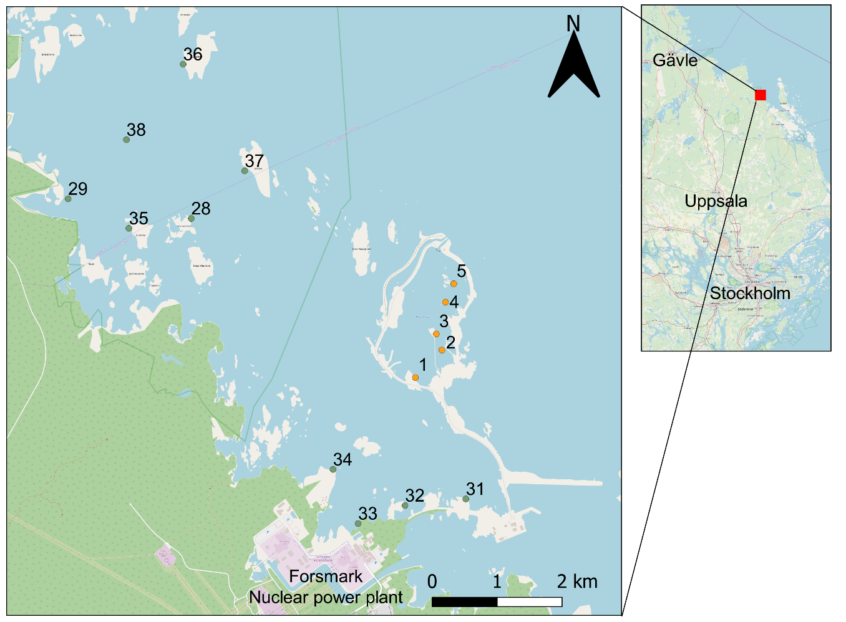

Figure 1. Map over study area with the fishing stations marked with numbers. Number 1-5 is located in the heated Biotest lake and number 31-34, 28-29 and 35-38 are stations in the reference area.

The purpose of the construction of the Biotest lake was to create opportunities to study effects of the cooling water from the power plant on the surrounding environment (Adill et al., 2013). The perch populations have therefore been monitored in the Biotest Lake and the reference area since the construction of the enclosure (Huss et al., 2019). All types of fishing (apart from the regular surveys) have been banned since the construction (Huss et al., 2019). The Biotest Lake was also provided with a grid at its outlet which, together with the strong current, prevented fish larger than 10 cm from migrating in and out of the area (Adill et al., 2013; Huss et al., 2019). The grid was removed in the spring 2004 and the Biotest Lake has since then been an open system (Adill et al., 2013), although the strong current caused by the through flow of water of ca 100 m3/s largely prevents immigration. This, together with genetic studies providing evidence for genetic differentiation (Björklund et al., 2015), suggests that the perch population inside the Biotest Lake and the population in the reference area were reproductively isolated during 1980-2003. All analyses in this report are based on data collected before 2004.

## 2.2 Study species

Eurasian perch (*Perca fluviatilis*), henceforth only perch, is a predatory freshwater fish that inhabits a wide range of habitats. It occurs in Swedish lakes, streams and coastal brackish water areas, with the exceptions of heavily flowing waters and extremely cold areas in the Swedish mountain areas (Froese and Pauly, 2019; Kullander et al., 2012). Perch is an opportunistic warm water species creating shoals in shallow vegetation rich areas nears the shore (Froese and Pauly, 2019; Kullander et al., 2012). Larvae and small juveniles of Baltic Sea perch feed primary on zooplankton, but the prey shifts towards macroinvertebrates and fish as the perch grow in body size (Jacobson et al., 2019). Perch reaches sexual maturity in 2-6 years for males and 3-7 years for females, but growth and age at sexual maturity vary considerably depending on life conditions (Kullander et al., 2012). Generally, the species grow slowly (Kullander et al., 2012). Eurasian perch can reach an age of 22 years and a total length of 61 cm but are usually significantly smaller. They are sexually size-dimorphic and females achieve a larger size than males (Kullander et al., 2012).

## 2.3 Data

To investigate whether there is a temperature related difference of key life history traits of perch, I examine mass-specific growth rates, fit ontogenetic growth models (von Bertalanffy growth model, VGBM (Bertalanffy, 1938)), and mortality rate. I also examine three commonly used size-based metrics: size-spectrum slopes, the upper percentiles of the length distribution, and the average length in the populations.

### Mass-specific and ontogenetic growth

Growth rates were estimated using annual back-calculated length-at-age data. Back-calculated age and body lengths of perch are obtained by analysing hard structures, such as otoliths and operculum bones. During winter when most fish species in Swedish waters do not grow, the translocation of calcium in the bone tissue ceases. This causes visible irregularities in the bony structures, so called annuli rings (Thoresson, 1996). The rings are comparable to annul rings on a tree and allow for determination of age and growth history by counting the rings and measuring the distance between rings. For perch, age determination was done by counting annual rings in operculum bones (with control counts done on otoliths), and growth history is measured in the operculum bones (Thoresson, 1996). The relationship between the distance of the annual rings and body length has been established based on measurements, which allows for estimation of length at age for each sampled individual based on the distance from the centre to the respective corresponding annual ring in the operculum bone (Thoresson, 1996). The relationship between fish length and the operculum radius is described by an exponential function: , where is the length of the fish, the operculum radius, *k* the intercept of the line, and *b* the slope of the line for the regression of log-fish length on log-operculum radius. For perch, = 19.45 cm, and (Thoresson, 1996). Back-calculated body lengths can then be obtained from the relationship , where = the back-calculated body length at length a, = the final body length (body length at catch) and = the distance from the centre to the annual ring corresponding to age . This equation assumes that the relationship between the operculum bone and the fish's body length does not change during its life. Further, length-at-age has been determined for females throughout the study period, and for males only during parts of it (Thoresson, 1992). My data analysis of growth rates will therefore only include length-at-age data of females.

The individual back-calculated length-at-age data used in this study provides multiple replicates within each individual and are therefore pseudo replications, unless accounted for in the statistical model. A random variation in growth rate is expected at the individual level, and the differences in growth rate will most likely persist through life. For instance, slow-growing individuals tend to remain slow-growing and fast-growing individuals tend to remain fast-growing (Kraak et al., 2019). These individual differences in growth rate are thought to result in that smaller, slow-growing individuals at each age will have a greater chance to escape fishing gears and survive another year, and fast-growing individuals have a greater chance to get caught at a young age than slow-growing individuals does – a phenomenon discovered by Rosa Lee (1912). The Rosa Lee-effect means that the age at which an individual is caught influences back-calculated length-at-age. Therefore, differences in age-distributions at catch of two samples can lead to erroneous conclusions about the causes of difference in back-calculated length-at-age. To address this, I chose to exclude fish with a catch age younger than 6 years, resulting in growth data where I can exclude growth effects due to Rosa Lee-effect and simplify interpretation of the effect of temperature. This also aids the convergence of the hierarchical model, as this will exclude individuals with too few data points. In 1983-1986 no fish with an age older than 6 years were caught (Figure S1, Appendix), whereupon these years were excluded in the analyses of size-specific growth rate. Hence, studied years will be 1987-2003, but since the data are back-calculated, the birth year for some individuals will be earlier (though after 1980). Additionally, assumptions made for the interpretation of the back-calculated length-at-age data is that the ages are accurately assigned to the sample.

When fitting ontogenetic growth curves (VBGM), I did not use back-calculated growth data but only length-at-age of each fish in the year it was caught (Ogle, 2013a) (1987-2003), in order to avoid fitting individual-level random effects in a more complex non-linear model.

### Mortality

Mortality estimation was conducted using catch curve analyses, whichrequires age-structured data. The catch data is length-based. To assign ages to lengths, I used annual length-at-age (1987-2003) data to produce population-specific age-length keys (ALK), using methods described by Isermann and Knight (2005) and Ogle, (2013a). The ALKs were then applied to annual length-frequency data (1987-2003) to obtain an age-distribution that was used to estimate mortality rates (). The catch data is in catch per unit effort (CPUE, in number of individuals per net and night) sampled with survey-gillnets during the same period as the back-calculated length-at-age data (1987-2003) in the heated Biotest lake and in the reference area. Fishing took place during one night each year in October in the Biotest lake and in August in the reference area when temperatures are most comparable between the two areas (Huss et al., 2019). Fish were classified into 2.5 cm length groups during 1987-2001, and into 1 cm length groups during 2001-2003. To express lengths in a common length standard, 1 cm intervals were converted into 2.5 cm intervals (full description of length group standardisation see Appendix). All data from fishing events with disturbance affecting the catch (e.g. seal damage, strong algal growth on the gears, clogging by drifting algae, boat traffic or other human inference) were removed. All length-frequency data from the Biotest Lake in 1999 and 2000 were removed as a consequence of disturbance on the fishing gear due to strong algal growth.

Population-specific ALKs were derived by splitting the data into each area and assigning all individuals in the back-calculated length-at-age data into 2.5 cm length categories. The given length category and assessed age are summarised as a proportion of that length category of each age. The proportion is used to allocate ages to individuals in the length-frequency data. The assignment of ages to the length-frequency data are semi-random, meaning that the exact expected number of fish with a given length interval of a given age will be assigned that age, but *which* of the fishes in the length interval is determined randomly (full description of the semi random ALKs see data analysis). The semi-randomness in the ALK leads to slightly different results each time the analysis is performed, which results in slightly different estimates of . To quantify the effects of the randomness on the outcome (i.e., on the difference in between the areas), the ALKs and subsequent estimates of were resampled 1000 times for each population to provide a sampling distribution of . To test for possible differences of the area specific estimates of **,** I used a permutation-test. The null hypothesis of the test is that there is no difference of between the areas. If the null hypothesis is true, the outcome of observed would be independent of the area from where the sample was taken. The test was performed by first calculating an average difference between the sampling distribution of of each area, and second to create a randomization distribution of differences in mean under the null hypothesis by randomly shuffling the area associated with each 5000 times. The latter visualises all of the possible outcomes of which are independent of area. These results were then compared with the mean difference of between the heated and the reference area. If the null hypothesis is true, the randomization distribution should centre around the estimate of mean difference of . If the null hypothesis is rejected, the estimate of mean difference of will be far from the randomization distribution meaning that the mortality rates are not independent of the difference in water temperature between the areas.

Length-at-age and length-frequency data were not collected on the same occasions (Thoresson, 1996), meaning that the individuals from the length-at-age and the length-frequency data do not come from the same catches, and that I cannot match them exactly. However, since the length-at-age data provides length-at-age (in order to account for differences in time of catch across years and areas), and not length-at-capture the exact timing of fishing will be of minor importance. Further, length-at-age has been determined for females throughout the study period, and for males only during parts of it (Thoresson, 1992). The age-sample for the ALK will therefore only include length-at-age data of females. In addition, length-frequency data consists of both females and males but information on length-specific sex ratio in the catches is not available for all years. Thus, the length-at-age relationship for the mortality analysis was based on the ages at lengths of females only but applied to the population length distribution as approximated by the length distribution in the catches. This can be considered as problematic since perch is sexually size-dimorphic (Heibo and Magnhagen, 2005). Despite this, I consider the results to be comparable as I analysed the two populations with the same assumption.

### Size structure

The size structure of the two populations was analysed using catch data of length frequencies in CPUE, as for the mortality analysis, in the heated Biotest lake and in the reference area.

Perch >12.5 cm have been shown to be caught efficiently in the survey-gillnets used (Sandström et al., 1995). However, my catch-curve analysis suggests that the smallest representative catch size was fish >17 cm in the Biotest lake and >12 cm in the reference area (Appendix, Figure S13). Since the same fishing gear has been used, the catchability is assumed to be the same in the two areas, providing comparable catches. However, because of mortality, the size structure of a closed population will always have number of individuals per size decreasing with size. Thus, only the decreasing part of the catches can be used to represent the true size structure of closed populations. Consequently, fish <17 cm were excluded from the size-spectrum analysis. Further, estimates of mean size was conducted using fish >12 cm since this most probably will represent the variation in sizes within the population (Sandström et al., 1995). Excluding small fish {12 < x < 17} cm would overlook a large part of the data including fish that, according to previous studies (Huss et al., 2019), can be expected to have a strong response to warming. A full description of smallest representative catch size, standardization of length groups and other filtering in the data is given in Appendix. Since processes such as growth are strongly linked to body mass, as well as to size structure I converted lengths to weight. For simplicity, this was done using the length-weight relationship (LWR): using the values of the intercept and the slope () provided in Froese et al. (2014) and Fishbase (Froese and Pauly, 2019).

## 2.4 Data analysis

All analyses were based on data from a period of 16 years (1987-2003). Years were either pooled (mortality analysis) within each area or treated as a random factor (all other analyses) in a hierarchal model. This allowed me to quantify life history traits and population structure emerging after long-term separation of thermal environments, while accounting for annual variation (and accounting for repeated measures within individuals, when using the back-calculated length-at-age data).

### Mass-specific and ontogenetic growth

#### Mass-specific growth rate

To investigate how temperature affects the mass-dependence of growth rate, I first calculated weight specific growth rate (SGR, % ) using annual data of individual back-calculated length-at-age of perch (1987-2003) and the equation:

|  |  |  |
| --- | --- | --- |
|  |  | (1) |

where is the weight at age and is the weight at age . The SGRs where then regressed against the geometric mean weights, to evaluate how changes with weight. To do this, I fit linear hierarchical models describing SGR as a function of geometric mean weight (both SGR and geometric mean weight on a natural log scale) area and their interaction (Equation 2, 3, 4). Because growth observations were based on back-calculated length-at-age, there were multiple observations per individual. Moreover, since data cover many years, non-independence might also arise if growth conditions are more similar in years close to each other in time. To account for these sources of non-independence, I fit models with a nested random intercept, to account for individual variation in growth within and between cohorts (Equation 2, 3, 4). The intercept reflects that individual and annual variation are manifested early in life when the fish are very small, and that this difference is maintained through life (Kraak et al., 2019). The random effects follow a normal distribution with unknown variance, allowing individually and yearly intercepts of the model to vary around the overall mean intercept (the fixed effects).

Model selection was carried out based on likelihood ratios, by comparing the most complex full model (with interaction, ) (Equation 2) with the subset model nested therein (without interaction) (Equation 3).

|  |  |
| --- | --- |
|  | (2) |
|  | (3) |
| In both models, the errors are assumed to be normally distributed. | (4) |

In these models, refers to observation, refers to year and refers to individual (nested within cohort). is the individual birth year and individual variation around the global intercept , with a mean of 0. If the model without interaction is *not* statistically different from the full model it is considered better because of its simpler structure.

#### von Bertalanffy Growth model

To characterize ontogenetic growth (growth as a function of age rather than mass), I fit the von Bertalanffy growth model (VBGM) using the typical form (Beverton, 1954; Beverton and Holt, 1957) on a cohort-basis using time-series of individual length-at-age. The typical parameterisation of the VBGM is defined as:

|  |  |  |
| --- | --- | --- |
|  |  | (5) |

Modified to:

|  |  |  |
| --- | --- | --- |
|  |  | (6) |

to better fit multiplicative error structure (see Appendix Figure S3, S4).

is the expected length at age (), is the average asymptotic length, is the Brody growth rate coefficient (i.e. how fast the fish approaches its ) and is a modelling construct that represents the time or age when the average length of the fish was zero. It is important to state that is not the maximum length, but rather an asymptote for the model of average length-at-age (i.e. the mean length of an infinitely old fish, where growth rate reaches zero). Thus, some fish in the population can be larger than the estimates of . Important is also that while describes how fast the fish approaches its , it is in unit , meaning that it is not an actual *growth rate,* as the units are in time rather than a change in length or mass over time as for growth (Ogle, 2013a). Since is an artificial parameter (Ogle, 2013b), with little biological relevance, I only considered and as response variables in the rest of the analysis.

To statistically evaluate differences in VBGM parameters due to higher temperatures, I fitted different nested models with varying combinations of specific and shared parameters between the two areas. The final model was selected by finding the best model (most likely, given data) using log likelihood ratio test (LRT), as described in Ogle (2013b). If the selected model had area-specific parameters, I assumed that it was due to mainly the large difference in water temperature between the experimentally heated and the reference area. The nested models are simplifications of the full (*General*) model (Table 1), and the best model was selected through a backwards step-wise model selection procedure as follows: Any “*one parameter in common*” model that is *not* statistically different from the *General model* is considered better. Each “*two parameters in common*” model is then compared with the best “*one parameter in common*” model in the same manner. The best “*two parameters in common*” model is then compared with the *Common model* (all parameters the same). The process stops when a more complex model is significantly different from a simpler subset model. For a detailed definition of the subset models see Table 1.

Table 1. Equation overview of the VBGM, compared using likelihood ratios. Each “one parameter in common” model is a subset of the general (full) model. Each “two parameters in common” model is a subset of two of the “one parameter in common” models. The Common model is a subset of each “two parameters in common” models.

|  |  |  |
| --- | --- | --- |
| **Name** | **Subset** | **Equation** |
| **General Model:**  Separate parameter estimates for individuals in each group. | All parameter estimates different |  |
| One parameter in common for individuals in each group. | Common |  |
|  | Common |  |
|  | Common |  |
| Two parameters in common for individuals in each group. | Common and |  |
|  | Common and |  |
|  | Common and |  |
| **Common Model** | All parameter estimates the same |  |

### Mortality

To estimate mortality (), I used a catch-curve regression method, together with a weighted catch-curve regression method described by Ogle (2013c). The catch-curve represents the sequential decline of observed abundance per age class – all years (1987-2003) pooled within each area – where the slope of the regression is . Further description and results of the weighted regression will be presented in Appendix.

For the **basic regression method**, a linear model with an interaction of area was fitted to test the effect of temperature (area) on using all age classes older than, and including, the age with the maximum catch. This model can be described as:

|  |  |  |
| --- | --- | --- |
|  | . | (7) |
|  |  | (8) |

Population-specific ALKs – needed to assign ages to lengths in the catch – were derived by splitting both the back-calculated length-at-age data and the length-frequency data by population. The ALK does not take into account that length-at-age can differ between years, as data from all years were pooled. Hence, any year effect will be overlooked in this analysis. All individuals in the back-calculated length-at-age data were then organized into 2.5 cm length categories. The assigned length category and assessed age are summarised as a proportion of that length category of each age. The proportion is used to assign ages to individuals in the length-frequency data. The assignment of ages to the length-frequency data are semi-random, meaning that the exact expected number of fish with a given length interval of a given age will be assigned that age. However, *which* of the fishes in the length interval is determined randomly.

The regression model is based on estimates of mortality rates from the observed sequential declines in cohorts of fish using a linear regression model (Ogle, 2013c). Catch-curve analysis suggests that representative catch age varied between the areas where it was ≥3 years for the population in the heated area, and ≥2 years for the population in the reference area (see catch-curve plot in the Appendix, Figure S5). Thus, I used ages ≥3 years for both areas. Catch-curve analyses assume that populations are closed, i.e. there is no immigration or emigration, mortality is independent of age and year, catchability of fish at all ages to the fishery is independent of age and year, the sample is unbiased regarding any specific age-groups (Ogle, 2013c). In real systems, these assumptions will be violated to some degree, some more than others, and the estimates should therefore be treated with some caution. Since the Biotest lake was provided with a grid during the study period, fish >10 cm were prevented from migrating in an out from the area (Adill et al., 2013; Huss et al., 2019). Further, immigration or emigration probably takes place mostly in the reference population as it occurs in the open sea.

### Size structure

The size-spectrum analysis is regression-based, and the slope describes how the fraction of individuals of each size changes with body size within the population. To characterize the size-spectrum slope, I fit hierarchical linear models describing the fraction of individual weights (i.e. at x = 0 g, all individuals in the population should be represented). To allow for between-year correlation (the size structure in 1994 is likely to be more similar to the size structure in 1995 than in 2003), I treat *catch year* as a random effect, allowing for annual variation in the intercept, which will be nested within each area. The random effects follow a normal distribution with unknown variance, allowing yearly intercepts of the model to vary around the overall mean intercept (the fixed effects).

The predictions from the hierarchical model were plotted against , according to the LCD (log of the cumulative distribution) method described by Edwards et al. (2017). Individual body weights were ranked from largest (rank 1) to smallest (rank *n*), and was plotted against , with one point for each body mass (Edwards et al., 2017). The LCD-method requires no extra binning of data as it includes all data points. The model can thus be written as:

|  |  |  |
| --- | --- | --- |
|  |  | (9) |
|  |  | (10) |
|  |  | (11) |

where , , are global coefficients to the area, weight and their interaction, and the intercept () is allowed to vary between years, , following a normal distribution with the mean of 0 and standard deviation . The slope of LCD will characterize how the fraction of values varies with body size (x) with great practical utility for detecting the effects of temperature upon fish population structure. The slope is expected to be negative and a steepening slope corresponds to fewer large individuals (Edwards et al., 2017). A more negative slope after warming thus indicates a relative decline in large individuals.

To allow for comparable results of the different methods estimating size-spectrum slopes, Edwards et al. (2017) related the slope of the regression with an exponent of mass ().

Derivation of :  
If represents the body mass of an individual fish (from a bounded power-law distribution), the probability density distribution for is:

|  |  |  |
| --- | --- | --- |
|  | | (12) |
| where | |  |
|  |  | (13) |
|  |

and represents possible values of , log is the natural logarithm, is an exponent and and are the minimum and maximum possible values of body mass (with ). The normalization constant *C* is calculated by solving . Assuming that the body mass of each individual fish is independently distributed according to equation 11 (Edwards et al., 2017), the resulting slope for the LCD method is approximately . Here I report .

To implement a thorough investigation of the largest part of the population – where the maximum size is reached and a difference between the areas can be expected, the upper percentiles of the length frequency distribution were examined by calculating the mean length and confidence intervals for the 90%, 92%, 94%, 96% and 98% percentile. Estimates of the average length of an individual fish were investigated using hierarchical model with year as random effect.

|  |  |
| --- | --- |
|  | (14) |
|  | (15) |
|  | (16) |

where is the global coefficients to the area and the intercept () is allowed to vary between years with , following a normal distribution with the mean of 0 and standard deviation .

### Statistical analyses

Data management, statistical analysis and figures were done in R (R Core Team, 2019) version 3.5.3 interfaced via R Studio version 1.2.5001 (RStudio Team, 2019), using the packages within the tidyverse (Wickham, 2017), and RColorBrewer (Neuwirth, 2014). For fitting VBGM to data I used the FSA package and descriptions produced by (Ogle et al., 2019) and (Ogle, 2013b). The packages lme4 (Bates et al., 2015), and lmerTest (Kuznetsova et al., 2017) were used to fit SGR. Population-specific ALKs and morality estimates were derived using the FSA (Ogle et al., 2019) and FSAdata packages (Ogle, 2019), together with R packages mentioned earlier. For size-spectra analysis I relied heavily on method description of fitting size spectra to data by Edwards et al. (2017), the packages lme4 (Bates et al., 2015), and lmerTest (Kuznetsova et al., 2017).Data and code are available from the author upon request.

All models require that some assumptions are met. These assumptions include that the variability about the model should be constant, that the residual errors are normally distributed, and that there are no influential outliers in the data. To test if these assumptions were met, I used visual inspection of residual and normal Q-Q plots.

# Results

## 3.1 Body growth and maximum body size

### Mass-specific growth rate

Analysis of specific growth rate, SGR, shows that the annual growth rate is faster in the warm area, but that the effect of body mass on growth is the same, as indicated by a higher intercept and a lack of support for a interaction (Figure 2). Likelihood ratio test shows that removing the interaction does not significantly affect the fit of the model, hence the subset model was considered as the best fit (Full Model ( interaction) compared with Subset Model (without interaction) gave ap-value of 0.43). However, the best-fit model shows a significant difference in the intercepts of the regression (p < 0.001), suggesting a temperature-growth response, as the intercept for the populations in the warmer water was higher than in the cooler reference area (Figure 2). A difference in the intercept but not in the slopes should be interpreted as a difference in magnitude but not in rate of change as fish grow in mass. This means there is no difference in the change of SGR with increasing weight between the two populations, but the *actual* growth rate is higher in the warmer water across all fish weights in comparison with the normal temperate reference area (Figure 2).

Labels in Figure 2 also show the mean SGR and for a specific age suggesting that the difference in SGR for age 1-4 is higher, and lower for age 5-8 in the heated area for fish in the heated Biotest lake. Note, however, that this is not a statistical result but only a possible outcome of how SGR is expected to change with age.

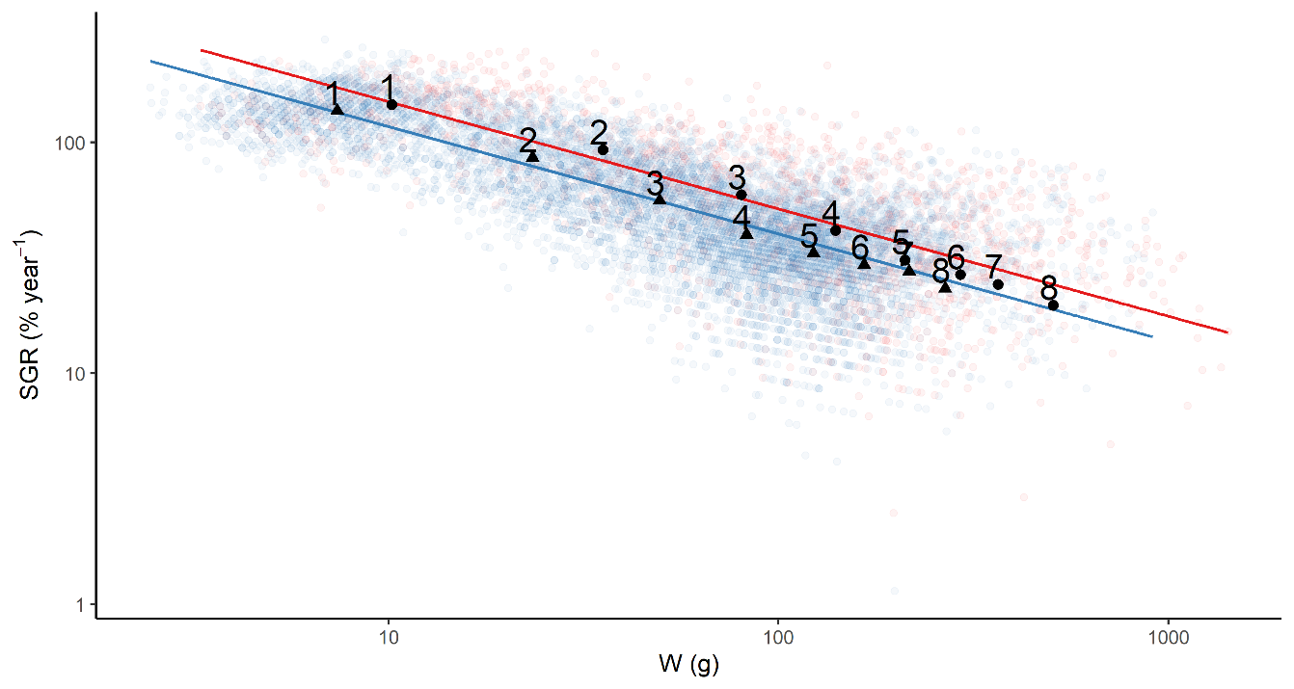

Figure 2. Weight specific growth in % per year versus weight, where the population in the warm water is in red and the reference population is in blue. Mean SGR and mean W were calculated to illustrate how SGR changes with increasing age. Labels show the mean SGR and W for each age 1-8 with circles for the Biotest lake and triangles for the reference area. Data points are jittered to visualize overlapping data points

### Von Bertalanffy growth model

The best VBGM based on likelihood ratio test included a difference in but not in between the areas, i.e. the *Common*  *Model* (Table 2). This model showed larger length-at-age for all ages in the heated water, as was found to be higher in the heated Biotest lake than in the reference area with natural temperatures (Figure 3A-B). Hence, the size of a fish reaching an age where they practically stop growing is expected to be the same in both populations, but fish growing in the warmer water are expected to approach this size faster.

Table 2. Results of the model selection of van Bertalanffy growth models using likelihood ratio test (LRT). Each “one parameter in common” model is fort compared with the general model (all parameters different). The best “one parameter in common” model is then compared to all “two parameters in common” models. Model considered as the best fit marked in bold.

|  |  |  |
| --- | --- | --- |
|  | **Comparison** | **p-value** |
| General Model | **Common** | **0.238** |
|  | Common | < 0.001 *** |
|  | Common | < 0.001 *** |
| Common | Common and | < 0.001 *** |
|  | Common and | < 0.001 *** |
|  | Common and | < 0.001 *** |

|  |  |  |  |
| --- | --- | --- | --- |
|  | A |  | B |
|  | |  | |

Figure 3. A) von Bertalanffy growth functions of length (in mm) at age (in year) perch in the heated Biotest lake (red) and the reference area (blue). B) Point estimates of K with 95% confidence interval. Red represent the population in the heated water, blue the reference population.

## 3.2 Mortality

The basic catch-curve regression method suggests a significantly higher mortality in the heated Biotest lake in comparison with the reference area (Figure 4A-B, Figure 5). The permutation-test clearly illustrates that the observed mean difference in between the populations falls far away from the randomization distribution (Figure 4A). This suggests that the mortality rates are not independent of the difference in water temperature between the areas, and that mortality is expected to be higher in the population exposed to the heated water (Figure 4B). The 2000 estimates of Z for each area in Figure 4B also illustrate the uncertainties in the catch curves. One single random catch curve regression illustrating the observed difference in is shown in Figure 5.

|  |  |  |  |
| --- | --- | --- | --- |
|  | A |  | B |
|  | |  | |

Figure 4. A) Histogram illustrates randomization distribution built by the permutation-test. Dotted blue line show the observed mean difference of . B) The 2000 estimates of used in the permutation test, red representing the population in the heated Biotest lake and blue the reference area. Data points are jittered to visualize overlapping data points.

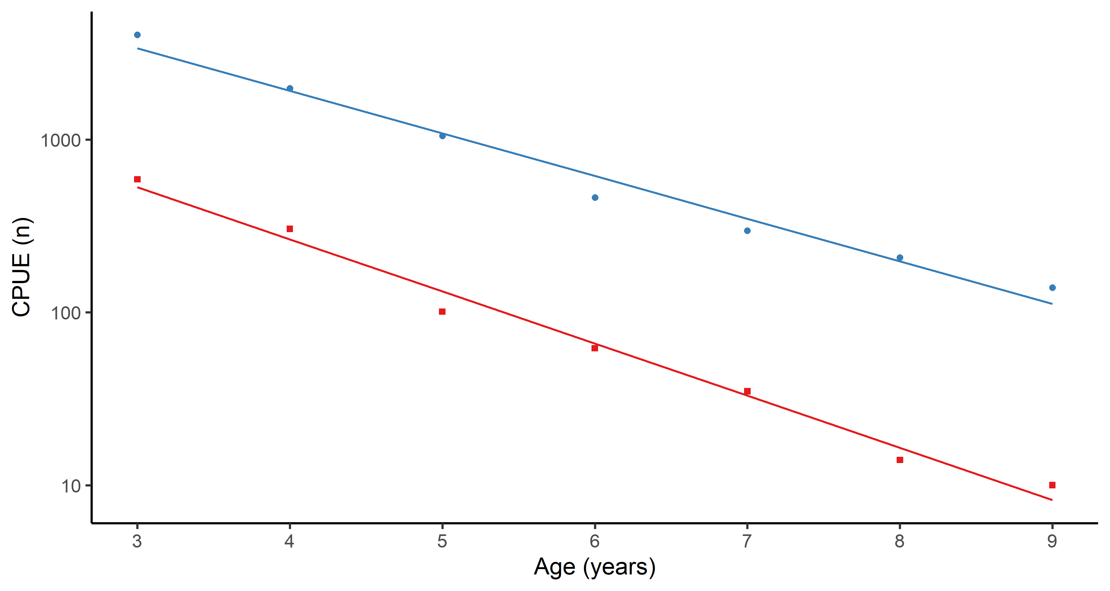

Figure 5. One scenario of the basic catch-curve estimates of natural mortality, where the slope is . Population in the warmer water in red and reference population in blue.

## 3.3 Size structure

Size-spectra for the two investigated populations fitted by the hierarchical *log cumulative distribution model* (LCD) are shown in Figure 6A. The slope of the size-spectrum showed a significant difference between the populations (p < 0.001), where the population in the warmer water had a less step slope (Figure 6A-B). The point estimate of and 95% confidence intervals estimated by the model are shown in Figure 6B to highlight differences in the slopes. for the population in the warmer water is estimated to be a less negative value, suggesting that the relative abundance of large individuals is higher in the heated Biotest lake compared to the population in the reference area with normal temperatures. Average length in the catches were also found to differ between the populations, such that it was larger (18 cm) in the warmer area than in the reference area (16 cm) (*p* < 0.001 ***) (using t-test). The upper percentiles of the length frequency distribution show that there is a distinct difference in lengths of the largest fish between the two areas, where it was consequently higher in the heated area (Figure 7B). The proportional frequencies of individuals ≥ 22.6 cm were found to be higher in the heated water, and individuals of the largest length group did not exist at all in the reference area throughout the time period (Figure 7A). Note that results illustrated in Figure 7A are not statistically tested as it only illustrates the frequency of individual fish in the different length groups. This means however, that the average length of the part of population belonging to the largest length classes was greater in the warm water (Figure 7B). The observed difference between the populations should be emphasized when the size-spectrum slope (Figure 6) is interpreted as it is based on ranked weights, and thus does not take into account that there is a difference in maximum length between the populations.

|  |  |  |  |
| --- | --- | --- | --- |
|  | A |  | B |
|  | |  | |

Figure 6. A) Natural log of the cumulative size distribution (points) and fitted size-spectrum slope for both populations (lines). Axes are log-binned for easier interpretation. The data points are jittered to visualize overlapping data points. B) Point estimates of exponent b with 95% confidence interval corresponding to the slope of the size-spectrum. Red represent the population in the heated water, blue the reference population.

|  |  |  |  |
| --- | --- | --- | --- |
|  | A |  | B |
|  | |  | |

Figure 7. A) Frequencies (%) of fish in each length group in the warm water compared to the reference area. B) The largest fish in the populations illustrated as mean length in the 90%, 92%, 94%, 96% and 98% percentile with 95% confidence interval. Red representing fish in the warm water, blue fish in the reference area.

# Discussion

I found that growth rates in the perch population exposed to elevated water temperature over a long time period (exposure 1980-2003, studied during 1987-2003) were higher compared to the reference population. Maximum length, mean length and length-at-age were also found to be higher. Mortality rates in this population were higher compared to the population in the reference area with normal ambient temperatures. However, despite the higher mortality rates, my results suggest that the perch population exposed to higher water temperatures had a shallower slope of its size spectrum, indicating a higher proportional abundance of large individuals compared to the reference population, likely due to the increased growth rates. Hence, temperatures in the Biotest lake increases growth rates, which seems to compensate for the higher mortality rates. Higher mortality will also lead to lower density, which also may benefit growth rates.

Results presented here are in contrast with previous observations of temperature induced changes in the mean (e.g. Daufresne et al., 2009) and maximum size (e.g. Baudron et al., 2014; van Rijn et al., 2017) of fish, as those researchers found negative responses of temperature on asymptotic or maximum body size. However, in contrast to the populations studied here, most studies to date are based on data from commercially fished populations (e.g. Baudron et al., 2014; van Rijn et al., 2017) where it is difficult to disentangle temperature from selective harvesting. In addition, it was recently found, in a large scale study of 28 exploited stocks, that the effects of fishing on fish size variation were significantly higher than that of temperature, and that fish stocks exposed to high fishing pressure were expected to be more responsive to the effect of temperature on their size structure (Tu et al., 2018). Thus, predicted temperature induced responses of an exploited population need not to be true for an unexploited population. Further, fishing alone is expected to result in smaller adult body sizes (Uusi‐Heikkilä et al., 2015). Here, I found that in an unexploited perch population, warming increased body growth, resulting in both larger length-at-age and mean length in the population.

The expected effects of temperature on individual growth rate were determined by the differences between species specific temperature optima and the ambient temperature (Neuheimer and Grønkjaer, 2012). During the time period 1989-2003 temperatures in the Biotest lake reached a maximum of ~24°C in August (with maximum observations slightly above 27°C), while summertime temperatures rarely exceeded 20 degrees in the reference area (Huss et al., 2019). Perch is an opportunistic warmwater species (Froese and Pauly, 2019; Kullander et al., 2012), and temperature optima decrease with body size, being close to 30°C for small individuals, and around 22°C for large (~30 cm) (Huss et al., 2019; Karås and Thoresson, 1992). Moreover, it has been shown that a temperature increase within the normal range is beneficial to body growth for most fish species, but that temperatures higher than optima can have the opposite effect (Neuheimer and Grønkjaer, 2012; Ohlberger, 2013; Thresher et al., 2011). Hence, the thermal optimum relative to the actual temperature will determine the course and magnitude of fish response in growth rate to climate warming (Ohlberger, 2013). The analysis of specific growth rate (SGR) showed no difference in the size-dependence of growth with warming (i.e. the decline in SGR with increased weights was the same for both populations), but the intercept was higher (i.e. higher SGR at each weight) in the warmer area. In Huss et al. (2019), temperature-dependent growth of perch was studied using some of the same data as in this study. Results from the time series analyses by Huss et al. (2019) showed that growth increased with temperature only among small-bodied perch, but that the difference in body size at age between the areas was maintained over life history. However, my study contrasts with these results as it shows that temperature increases growth rates equally for all sizes (at sub-optimum temperatures) and that there is no support for interactive effects of body mass and temperature in these temperature ranges, also found in Elliott and Hurley (1995), but see (Björnsson and Steinarsson, 2002) who, just as Huss et al. (2019), found that temperature has a greater effect on the growth rate of small juvenile fish than on that of large. In the study by Huss et al. (2019) were only a selected set of back-calculated growth trajectories used, within a defined size class within each age (0-4 year olds) (i.e. all individuals within each size class studied were of the same age) to calculate growth trajectories but avoid size-at-age changes that could potentially confound growth comparisons in their analyses of growth variation over time between the two areas. While this allows for comparison of temperature effects without confounding size and age effects, it strongly reduces the number of individuals analysed. I therefore chose to compare all sizes and ages (1-8 year olds) without such filtering, and instead address this using a hierarchical model. As I only studied differences between the two areas, and treated annual variation as a random factor, potential trends in size-at-age confounding growth estimates were not a problem for my analyses. To address the age-dependency of growth, I chose to analyse the effect of age on growth by fitting a VBGM, as well as visualizing the effect of age in the SGR plot. Further, both studies found that size-at-age was larger in the heated Biotest lake, which may explain the divergent results, as the large (probably fast growing) individuals from the Biotest lake and small (probably slow growing) individuals were excluded from the growth analysis in Huss et al. (2019).

During the warmest month in the Biotest Lake, water temperatures are close to optimum growth temperatures (predicted from bioenergetics models) for fish >20 cm (Huss et al., 2019), hence growth can be expected to cease or decrease for fish >20 cm during this period. Since results here suggest a higher growth rate for all sizes in the Biotest lake, positive effects from warming seem to compensate for potential negative effects on growth during the hottest months. This could be explained by a longer and warmer growth season for perch in the heated area resulting in higher annual growth rates. Further, it is suggested that the perch in the Biotest lake show indication of having adapted to their warmer habitat, by findings of differentiation of physiological adjustments of the mitochondrial functions (Pichaud et al., 2019), which also may explain the observed higher growth rates. However, the age-based VBGM-analysis yielded a higher but the same for the population exposed to warmer water compared to the reference population. These results suggest that the average asymptotic (i.e. maximum body) size of perch is the same in both areas, hence no support for a negative effect on maximum body size and temperature in these temperature ranges, contrasting (Baudron et al., 2014; van Rijn et al., 2017), but in line with the experimental study by Barneche et al. (2019). Further is it predicted that the relationship between and length at maturity is constant (Thorson et al., 2017), and since and also is correlated similar relationship could exist between K and length at maturity, suggesting that the fast growing perch in the Biotest lake could reach sexual maturity at an earlier age. Size at maturity is also predicted to change with temperature in such a way that length at sexual maturity decreases with increased temperature (Berrigan and Charnov, 1994), also supporting that there may be an earlier sexual maturation in the heated area. However, data on length at maturity would be required to support this assumption.

A higher but the same suggest that the growth rate is higher for young *ages* in the Biotest lake, and lower for old *ages* in comparison with the reference area. This is also illustrated in the SGR analysis where mean and for a specific age shows that is slightly higher for young fish in the heated area, but lower for older ages. Note, however, that the mean and for a specific age is not a statistical result (as I did not include age as an explanatory variable in the model of ) but rather a possible outcome of how SGR is expected to change over mean age within the population. However, an interpretation of results from both the VBGM and the SGR may be that fish length-at-age is greater in the Biotest Lake and growth rates are expected to decrease with increasing size (Björnsson and Steinarsson, 2002). In other words, fish of the same age will have different growth rates since they have different sizes – a 6-year-old in the Biotest lake is larger than a 6-year-old in the reference area resulting in slower growth at older ages of the Biotest-perch.

In addition to the direct physiological effects of temperature on body growth, the optimum temperature for growth and the maximum temperature that maintain growth are both expected to be lowered with reduced food intake. For example, Elliott and Hurley (2000) show that the thermal optima for growth rate of brown trout (*Salmo trutta*) is lower when food resources are limited compared to unlimited food supply. Hence, the interaction between temperature and population density will determine the direction and magnitude of growth rate response to climate warming. CPUE of perch from the Biotest Lake were consistently lower compared to the reference area during the entire investigation period (Figure S14, Appendix), which could indicate, all else equal, that the fish population in the heated area experience less competition for food. To verify such a relationship, diet data and quantification of food resource would be required. However, the lower CPUE in the Biotest lake may be consistent with the higher mortality found in the perch population therein compared to in the reference area, but it may also be due to that the Biotest Lake is a relatively small and closed lake, while the reference area is in the open sea. A similar response has also been observed in several natural populations of Chinook salmon (*Oncorhynchus tshawytscha*) where fish exposed to warmer temperatures were larger when held at low compared to at high densities (Crozier et al., 2010). Additionally, a study of 200 years (1804-2003) abundance time series data of Atlantic salmon (*Salmo salar*) in the Baltic Sea shows that periods of warm temperatures were associated with larger sized fish at low abundance, and periods of cold temperatures were characterized by small sized fish but at high abundance (Huusko and Hyvaerinen, 2012). Hence, a less dense fish population results in more energy available per individual fish, which thus compensates for the temperature-induced increase in metabolic rate. This suggests that temperature effects on growth are not independent of how temperature influences densities via mortality.

Estimates of mortality for perch exposed to high water temperature over the 16-year time period were higher than for perch in the normally temperate area. Similar patterns have been observed in laboratory studies on cod (*Gadus morhua*), which showed that mortality increased with temperature (Björnsson et al., 2001). A decrease in the relative abundance of eelpout (*Zoarces viviparous*) has also been found in field studies (spanning over a 35-year period), reflecting a higher mortality of large individuals in hot summers (Pörtner and Knust, 2007). Further, Gislason et al., (2010) suggest from a literature review of publications on mortality for marine and brackish water fish species that mortality is positively related to the von Bertalanffy growth parameter , with the underlying cause explained by temperature-induced changes in physiological growth processes. This has also been suggested by Pauly (1980), who considered that fishes in warmer water, because of their higher metabolic rates, need to feed more frequently, resulting in higher exposure to predators, which in turn impose greater mortality. Pauly (1981) did, however, also suggest that higher mortality rates can be due to size limitation set by the gill area to volume ratio. Hence, one possible explanation of the higher observed mortality rate in the warmer Biotest lake could be the higher growth rate, or, more directly, higher metabolic rates as proposed by Pauly (1981), Brown et al. (2004), and Munch and Salinas (2009) or/and increased exposure to predators Pauly (1980). Hence, the higher mortality in the Biotest lake may either be caused by higher mortality followed by consistently higher metabolism of perch in the Biotest lake, or followed sudden increases in metabolic rate at lethal temperatures during hot summer days, also found by Pörtner and Knust (2007).

Previous studies on natural mortality of fish populations (e.g. Thorson et al., 2017) characterize macro-ecological patterns of mortality, where it is not evident if responses to warming also can be derived from latitudinal relationships. Here, I analysed mortality rates of two adjacent populations of perch experiencing different temperatures. This provided a unique opportunity to study how mortality is expected to respond to warming in natural populations, and that the observed higher mortality may be explained by temperature and not due to latitudinal relationships. The immediate effects of temperature on life history variables of perch in the Biotest lake and in the same reference area have also been studied by Sandström et al. (1995) (only using stations 28, 29, 35, 36, 37, 38 in the reference area, see Figure 1). The aforementioned study is based on time series data of perch prior and after the nuclear power plant started to operate 1978-1990. Higher mortality rates were observed in the Biotest lake in comparison to the reference population directly after onset of the power plant. At the end of the study period, there was an indication that the mortality rate had returned to levels that were close to normal. As I quantified how accumulated effects of temperature over a long period of time, my study differs from the direct mortality responses at the operation start of the nuclear power plant studied by Sandström et al. (1995), which may explain the disagreement of our results.

Given that I found clear differences in growth trajectories and size-at-age, it is of high ecological importance to evaluate the effects on the population-level. Fish population size structure is determined by individual growth rate and population mortality rate. The size-spectra analysis of length frequency data spanning over 16 years shows that the relative abundance of large individuals was higher in the heated Biotest lake compared to the reference population, and that the largest length group did not exist at all in the reference population. These results may suggest that the positive effects of temperature on growth rates can compensate for the higher mortality in the heated area. Note, however, that the size-spectrum analysis only applies in relative numbers and that the total abundance in the Biotest lake was lower than it was in the reference population. Further, the largest length groups only existed in the Biotest population, and the size-spectrum analysis is based on ranked weights and does not take into account that there is a difference in maximum length between the populations, indicating that the size structure in the Biotest lake is more diverse than the size-spectrum reveals. Large individuals are expected to have a higher reproductive success than small ones (Hixon et al., 2013; Hsieh et al., 2010), and a greater diversity of sizes involved in reproduction may increase population resilience. Hence, the higher proportional abundance of large individuals in the Biotest lake could have a compensating effect for the higher mortality rate by also increasing the total reproduction. This might also support findings that an undisturbed population is better equipped to cope with a changing climate than an exploited population (Tu et al., 2018), since most commercial fishing represents size-selective removal of larger individuals (Barnett et al., 2017; Uusi‐Heikkilä et al., 2015).

The SGR model assumes the relationship between and geometric mean weight to be linear on a log-log scale. Unfortunately, results from the analysis suggest that the data do not perfectly follow a power law function, as is commonly assumed (e.g. Brown et al 20014) (Figure S2, Appendix). This means that growth rate in this particular case does not decrease linearly with geometric mean weight on a log-log scale, as assumed by the model. This can be considered problematic as there can be a difference in how much the date deviates from a power law function between the populations, which can give systematic misinterpretations in the comparison between the populations. Still, I choose to use SGR since it is a commonly used method for describing growth rates of fish (Björnsson et al., 2001; Björnsson and Steinarsson, 2002; Dutil et al., 2008; Huss et al., 2019). I would also caution that the ALK used for mortality analyses was based on female length-at-age only, and the length-frequency data consists of both males and females, meaning that the length-at-age relationship for the mortality analysis was based on the lengths of females only. This can be considered as problematic since perch are sexually size-dimorphic (Heibo and Magnhagen, 2005), and preliminary analyses suggest that perch response to warming is sex dependent (van Dorst et al., In prep.). Hence, males in the length-frequency data will be based on female responses to warming, and additionally they will be assigned a younger age than is likely, both of which can contribute to uncertainty to conclusions made from the mortality analysis.

Results from the size-spectra analysis suggest that the data do not perfectly follow a power law function (see residual plot in Appendix, Figure S15). However, I chose to use a linear hierarchical model since I believe that there is a correlation of size structures between years, i.e. the size structure in 1994 is expected be more similar to the size structures in 1995 than in 2003, which is appropriately described by a hierarchical model. A non-linear method (as the maximum likelihood estimate method described by (Edwards et al., 2017)), would probably have given a more correct fit to the data, but in order to avoid fitting a more complex non-linear model I choose to use a linear hierarchical model with year as random effect. All of these are important uncertainties that could be addressed in future work. Despite these, I consider the results to be comparable as I analysed the two populations with the same presumption.

# Conclusions

In conclusion, this study offers a unique demonstration how warming affects life history traits, such as growth, maximum size and lifespan (population-level mortality), and how that affects population size structure in an unexploited fish population.

Using 16 years of experimental data of two perch populations, one exposed to high water temperatures and one in a normal temperate reference area, I found evidence that perch populations exposed to a high water temperature have 1) faster growth rate at all weights, resulting in larger sizes-at-age, 2) no expected difference in maximum body size (), but fish growing in the warmer water is expected to approach this size faster,3) even though the weight specific growth rate ( was higher for all weights, the body growth coefficient () and the maximum body size ( of the VBGM indicated that growth may be higher for young ages and lower for old ages in the heated water,4) higher mortality rates, 5) a greater average length in the population and6) higher proportional number of large individuals, compared to the population in the non-heated reference area.

Finally, I want to point out that the interaction between growth, mortality, size structure and temperature of fish is highly complex, and the expected temperature induced responses of an unexploited population need not to be true for an exploited population. Here, I found no evidence of declining body sizes of older individuals contrasting the more commonly reported declines in adult body size – often from studies on exploited populations or experimental studies – described by the TSR. Instead I found increased growth rates for all sizes in the warmer water, whereas the TSR suggests that growth rate should only increase for smaller individuals. This suggests that accurate predictions of fish responses to climate warming need to recognize that responses may vary depending on the magnitude of the temperature increase, in relation to species- and size-specific temperature optima, and most importantly that it is important to derive life-history changes as a result of warming in undisturbed populations. Additionally, even though temperatures in the Biotest lake are shown to have a positive effect on growth rate and maximum body size (higher growth rate and larger maximum size), they increase mortality rates. To this I would add, that it is difficult to say whether results from this single-species study is general. My findings call for further studies to evaluate the generality of how life history traits of fish (in unexploited populations) will respond to climate warming, and to apply this in future conservation strategies in a changing climate.

# References

Adill, A., Mo, K., Sevastik, A., Olsson, J., Bergström, L., 2013. Biologisk recipientkontroll vid Forsmarks kärnkraftverk Sammanfattande resultat av undersökningar fram till år 2012.

Atkinson, D., 1994. Temperature and Organism Size—A Biological Law for Ectotherms?, in: Advances in Ecological Research. Elsevier, pp. 1–58. https://doi.org/10.1016/S0065-2504(08)60212-3

Barneche, D.R., Jahn, M., Seebacher, F., 2019. Warming increases the cost of growth in a model vertebrate. Funct. Ecol. 33, 1256–1266. https://doi.org/10.1111/1365-2435.13348

Barneche, D.R., Robertson, D.R., White, C.R., Marshall, D.J., 2018. Fish reproductive-energy output increases disproportionately with body size. Science 360, 642–645. https://doi.org/10.1126/science.aao6868

Barnett, L.A.K., Branch, T.A., Ranasinghe, R.A., Essington, T.E., 2017. Old-Growth Fishes Become Scarce under Fishing. Curr. Biol. 27, 2843-2848.e2. https://doi.org/10.1016/j.cub.2017.07.069

Bates, D., Machler, M., Bolker, B., Walker, S., 2015. Fitting Linear Mixed-Effects Models Using lme4. J. Stat. Softw. 67, 1–48. https://doi.org/10.18637/jss.v067.i01

Baudron, A.R., Needle, C.L., Marshall, C.T., 2011. Implications of a warming North Sea for the growth of haddock Melanogrammus aeglefinus. J. Fish Biol. 78, 1874–1889. https://doi.org/10.1111/j.1095-8649.2011.02940.x

Baudron, A.R., Needle, C.L., Rijnsdorp, A.D., Tara Marshall, C., 2014. Warming temperatures and smaller body sizes: synchronous changes in growth of North Sea fishes. Glob. Change Biol. 20, 1023–1031. https://doi.org/10.1111/gcb.12514

Bergmann, C., 1847. Ueber die Verhaltnisse der Warmeokonomie der Thierezuihrer Grosse. Gottinger Studien. Sci. Res. Publ. 3.

Berkeley, S.A., Chapman, C., Sogard, S.M., 2004. Maternal Age as a Determinant of Larval Growth and Survival in a Marine Fish, Sebastes melanops. Ecology 85, 1258–1264. https://doi.org/10.1890/03-0706

Berrigan, D., Charnov, E.L., 1994. Reaction Norms for Age and Size at Maturity in Response to Temperature: A Puzzle for Life Historians. Oikos 70, 474–478. https://doi.org/10.2307/3545787

Bertalanffy, L. von, 1938. A Quantitative Theory of Organic Growth (Inquiries on Growth Laws. II). Human Biology 10. 181–213.

Beverton, R.J.H., 1954. Notes on the use of theoretical models in the study of the dynamics of exploited fish populations. Miscellaneous Contribution 2, United States Fishery Laboratory, Beaufort, North Carolina.

Beverton, R.J.H., Holt, S.J., 1993. On the dynamics of exploited fish populations, Fisheries Investigations. United Kingdom Ministry of Agriculture and Fisheries.

Björklund, M., Aho, T., Behrmann-Godel, J., 2015. Isolation over 35 years in a heated biotest basin causes selection on MHC class IIß genes in the European perch (Perca fluviatilis L.). Ecol. Evol. 5. https://doi.org/10.1002/ece3.1426

Björnsson, B., Steinarsson, A., 2002. The food-unlimited growth rate of Atlantic cod ( *Gadus morhua* ). Can. J. Fish. Aquat. Sci. 59, 494–502. https://doi.org/10.1139/f02-028

Björnsson, B., Steinarsson, A., Oddgeirsson, M., 2001. Optimal temperature for growth and feed conversion of immature cod ( Gadus morhua L.). ICES J. Mar. Sci. 58, 29–38. https://doi.org/10.1006/jmsc.2000.0986

Brown, J.H., Gillooly, J.F., Allen, A.P., Savage, V.M., West, G.B., 2004. TOWARD A METABOLIC THEORY OF ECOLOGY. Ecology 85, 1771–1789. https://doi.org/10.1890/03-9000

Cheung, W.W.L., Sarmiento, J.L., Dunne, J., Frölicher, T.L., Lam, V.W.Y., Deng Palomares, M.L., Watson, R., Pauly, D., 2013. Shrinking of fishes exacerbates impacts of global ocean changes on marine ecosystems. Nat. Clim. Change 3, 254–258. https://doi.org/10.1038/nclimate1691

Crozier, L.G., Zabel, R.W., Hockersmith, E.E., Achord, S., 2010. Interacting effects of density and temperature on body size in multiple populations of Chinook salmon. J. Anim. Ecol. 79, 342–349. https://doi.org/10.1111/j.1365-2656.2009.01641.x

Daufresne, M., Lengfellner, K., Sommer, U., 2009. Global warming benefits the small in aquatic ecosystems. Proc. Natl. Acad. Sci. 106, 12788–12793. https://doi.org/10.1073/pnas.0902080106

Dutil, J.-D., Jabouin, C., Larocque, R., Desrosiers, G., Blier, P.U., 2008. Atlantic cod (Gadus morhua) from cold and warm environments differ in their maximum growth capacity at low temperatures. Can. J. Fish. Aquat. Sci. 65, 2579–2591. https://doi.org/10.1139/F08-159

Edwards, A.M., Robinson, J.P.W., Plank, M.J., Baum, J.K., Blanchard, J.L., 2017. Testing and recommending methods for fitting size spectra to data. Methods Ecol. Evol. 8, 57–67. https://doi.org/10.1111/2041-210X.12641

Elliott, J.M., Hurley, M.A., 2000. Optimum energy intake and gross efficiency of energy conversion for brown trout, Salmo trutta, feeding on invertebrates or fish. Freshw. Biol. 44, 605–615. https://doi.org/10.1046/j.1365-2427.2000.00605.x

Elliott, J.M., Hurley, M.A., 1995. The Functional Relationship between Body Size and Growth Rate in Fish. Funct. Ecol. 9, 625. https://doi.org/10.2307/2390153

FAO, 2018. The State of World Fisheries and Aquaculture 2018 - Meeting the sustainable development goals. Rome.

Forster, J., Hirst, A.G., Atkinson, D., 2012. Warming-induced reductions in body size are greater in aquatic than terrestrial species. Proc. Natl. Acad. Sci. 109, 19310–19314. https://doi.org/10.1073/pnas.1210460109

Froese, R., Pauly, D., 2019. FishBase. World Wide Web electronic publication. www.fishbase.org, version (08/2019). [WWW Document]. URL https://www.fishbase.se/summary/Perca-fluviatilis.html (accessed 2.8.20).

Froese, R., Thorson, J.T., Reyes, R.B., 2014. A Bayesian approach for estimating length-weight relationships in fishes. J. Appl. Ichthyol. 30, 78–85. https://doi.org/10.1111/jai.12299

Gislason, H., Daan, N., Rice, J.C., Pope, J.G., 2010. Size, growth, temperature and the natural mortality of marine fish: Natural mortality and size. Fish Fish. 11, 149–158. https://doi.org/10.1111/j.1467-2979.2009.00350.x

Griffiths, D., Harrod, C., 2007. Natural mortality, growth parameters, and environmental temperature in fishes revisited. Can J Aquat Sci 64, 249–255. https://doi.org/10.1139/F07-002

Heibo, E., Magnhagen, C., 2005. Variation in age and size at maturity in perch (Perca fluviatilis L.), compared across lakes with different predation risk. Ecol. Freshw. Fish 14, 344–351. https://doi.org/10.1111/j.1600-0633.2005.00108.x

Hixon, M., Johnson, D., Sogard, S., 2013. BOFFFFs: On the importance of conserving old-growth age structure in fishery populations. ICES J. Mar. Sci. 71, 2171–2185. https://doi.org/10.1093/icesjms/fst200

Hsieh, C., Yamauchi, A., Nakazawa, T., Wang, W.-F., 2010. Fishing effects on age and spatial structures undermine population stability of fishes. Aquat. Sci. 72, 165–178. https://doi.org/10.1007/s00027-009-0122-2

Huey, R.B., Kingsolver, J.G., 2019. Climate Warming, Resource Availability, and the Metabolic Meltdown of Ectotherms. Am. Nat. 194, E140–E150. https://doi.org/10.1086/705679

Huss, M., Lindmark, M., Jacobson, P., Dorst, R.M. van, Gårdmark, A., 2019. Experimental evidence of gradual size-dependent shifts in body size and growth of fish in response to warming. Glob. Change Biol. 25, 2285–2295. https://doi.org/10.1111/gcb.14637

Hutchings, J., Myers, R., 1993. Effect of Age on the Seasonality of Maturation and Spawning of Atlantic Cod, Gadus morhua, in the Northwest Atlantic. Can. J. Fish. Aquat. Sci. 50, 2468–2474. https://doi.org/10.1139/f93-271

Huusko, A., Hyvaerinen, P., 2012. Atlantic salmon abundance and size track climate regimes in the Baltic Sea. Boreal Environ. Res. 17, 139–149.

Isermann, D., Knight, C., 2005. A Computer Program for Age–Length Keys Incorporating Age Assignment to Individual Fish. North Am. J. Fish. Manag. 25, 1153–1160. https://doi.org/10.1577/M04-130.1

Jacobson, P., Bergström, U., Eklöf, J., 2019. Size-dependent diet composition and feeding of Eurasian perch (Perca fluviatilis) and northern pike (Esox lucius) in the Baltic Sea. Boreal Environ. Res. 24, 137–153.

Jennings, S., Blanchard, J.L., 2004. Fish abundance with no fishing: predictions based on macroecological theory. J. Anim. Ecol. 73, 632–642. https://doi.org/10.1111/j.0021-8790.2004.00839.x

Karås, P., Thoresson, G., 1992. An application of a bioenergetics model to Eurasian perch (Perca fluviatilis L.). J. Fish Biol. 41, 217–230. https://doi.org/10.1111/j.1095-8649.1992.tb02652.x

Kraak, S.B.M., Haase, S., Minto, C., Santos, J., 2019. The Rosa Lee phenomenon and its consequences for fisheries advice on changes in fishing mortality or gear selectivity. ICES J. Mar. Sci. 76, 2179–2192. https://doi.org/10.1093/icesjms/fsz107

Kullander, S.O., Nyman, L., Jilg, K., Delling, B., 2012. Nationalnyckeln till Sveriges flora och fauna. Strålfeniga fiskar. Acitinopterygii. ArtDatabanken, SLU, Uppsala.

Kuznetsova, A., Brockhoff, P.B., Christensen, H.B., 2017. lmerTest Package: Tests in Linear Mixed Effects Models. J. Stat. Softw. 67 1-48 67, 1–48. https://doi.org/10.18637/jss.v082.i13

Laffoley, D., Baxter, J.M. (Eds.), 2016. Explaining Ocean Warming: Causes, scale, effects and consequences. IUCN, International Union for Conservation of Nature. https://doi.org/10.2305/IUCN.CH.2016.08.en

Lee, R.M., 1912. An investigation into the methods of growth determination in fishes. Cons. Perm. Int. Pour L’Exploration Mer Publ. Circonstance.

Lefevre, S., McKenzie, D.J., Nilsson, G.E., 2017. Models projecting the fate of fish populations under climate change need to be based on valid physiological mechanisms. Glob. Change Biol. 23, 3449–3459. https://doi.org/10.1111/gcb.13652

Munch, S.B., Salinas, S., 2009. Latitudinal variation in lifespan within species is explained by the metabolic theory of ecology. Proc. Natl. Acad. Sci. U. S. A. 106, 13860–13864. https://doi.org/10.1073/pnas.0900300106

Neubauer, P., Andersen, K.H., 2019. Thermal performance of fish is explained by an interplay between physiology, behaviour and ecology. Conserv. Physiol. 7, coz025. https://doi.org/10.1093/conphys/coz025

Neuheimer, A.B., Grønkjaer, P., 2012. Climate effects on size-at-age: growth in warming waters compensates for earlier maturity in an exploited marine fish. Glob. Change Biol. 18, 1812–1822. https://doi.org/10.1111/j.1365-2486.2012.02673.x

Neuwirth, E., 2014. RColorBrewer: ColorBrewer Palettes.

Ogle, D.H., 2019. FSAdata: Fisheries Stock Analysis, Datasets.

Ogle, D.H., 2013a. fishR Vignette – Von Bertalanffy.

Ogle, D.H., 2013b. fishR Vignette – Age-Length Keys.

Ogle, D.H., 2013c. fishR Vignette - Catch Curve Estimates of Mortality.

Ogle, D.H., Wheeler, P., Dinno, A, 2019. FSA: Fisheries Stock Analysis.

Ohlberger, J., 2013. Climate warming and ectotherm body size – from individual physiology to community ecology. Funct. Ecol. 27, 991–1001. https://doi.org/10.1111/1365-2435.12098

Pauly, D., 1981. The relationships between gill surface area and growth performance in fish: A generalization of von Bertalanffy’s theory of growth. Meeresforschung 28, 251–282.

Pauly, D., 1980. On the interrelationships between natural mortality, growth parameters, and mean environmental temperature in 175 fish stocks. ICES J. Mar. Sci. 39, 175–192. https://doi.org/10.1093/icesjms/39.2.175

Pauly, D., Cheung, W.W.L., 2018. Sound physiological knowledge and principles in modeling shrinking of fishes under climate change. Glob. Change Biol. 24, e15–e26. https://doi.org/10.1111/gcb.13831

Pichaud, N., Ekström, A., Breton, S., Sundström, F., Rowinski, P., Blier, P.U., Sandblom, E., 2019. Cardiac mitochondrial plasticity and thermal sensitivity in a fish inhabiting an artificially heated ecosystem. Sci. Rep. 9, 17832. https://doi.org/10.1038/s41598-019-54165-3

Pörtner, H.O., Knust, R., 2007. Climate change affects marine fishes through the oxygen limitation of thermal tolerance. Science 315, 95–97. https://doi.org/10.1126/science.1135471

Purchase, C.F., Brown, J.A., 2001. Stock-specific changes in growth rates, food conversion efficiencies, and energy allocation in response to temperature change in juvenile Atlantic cod. J. Fish Biol. 58, 36–52. https://doi.org/10.1111/j.1095-8649.2001.tb00497.x

R Core Team, 2019. R: A Language and Environment for Statistical Computing. R Foundation for Statistical Computing, Vienna, Austria.

Roney, N.E., Oomen, R.A., Knutsen, H., Olsen, E.M., Hutchings, J.A., 2018. Fine-scale population differences in Atlantic cod reproductive success: A potential mechanism for ecological speciation in a marine fish. Ecol. Evol. 8, 11634–11644. https://doi.org/10.1002/ece3.4615

RStudio Team, 2019. RStudio: Integrated Development Environment for R. RStudio, Inc., Boston, MA.

Sandstrom, O., Neuman, E., Thoresson, G., 1995. Effects of temperature on life history variables in perch. J. Fish Biol. 47, 652–670. https://doi.org/10.1111/j.1095-8649.1995.tb01932.x

Thoresson, G., 1996. GUIDELINES FOR COASTAL FISH MONITORING.

Thoresson, G., 1992. HANDBOK FÖR KUSTUNDERSÖKNINGAR - Recipientkontroll. Fiskeriverket. Kustrapport 1992:4. Fiskeriverket. Kustrapport 1992:4.

Thorson, J.T., Munch, S.B., Cope, J.M., Gao, J., 2017. Predicting life history parameters for all fishes worldwide. Ecol. Appl. 27, 2262–2276. https://doi.org/10.1002/eap.1606

Thresher, R., Lyle, J., Semmens, J., Neuheimer, A., 2011. Tolerance limit for fish growth exceeded by warming waters. Nat. Clim. Change 1. https://doi.org/10.1038/nclimate1084

Thresher, R.E., Koslow, J.A., Morison, A.K., Smith, D.C., 2007. Depth-mediated reversal of the effects of climate change on long-term growth rates of exploited marine fish. Proc. Natl. Acad. Sci. 104, 7461–7465. https://doi.org/10.1073/pnas.0610546104

Tu, C.-Y., Chen, K.-T., Hsieh, C., 2018. Fishing and temperature effects on the size structure of exploited fish stocks. Sci. Rep. 8, 1–10. https://doi.org/10.1038/s41598-018-25403-x

Uusi‐Heikkilä, S., Whiteley, A.R., Kuparinen, A., Matsumura, S., Venturelli, P.A., Wolter, C., Slate, J., Primmer, C.R., Meinelt, T., Killen, S.S., Bierbach, D., Polverino, G., Ludwig, A., Arlinghaus, R., 2015. The evolutionary legacy of size-selective harvesting extends from genes to populations. Evol. Appl. 8, 597–620. https://doi.org/10.1111/eva.12268

van Dorst, R., Nurminen, L., Gårdmark, A., Estlander, S., Huuskonen, H., Kahilainen, K.K., Olin, M., Rask, M., Huss, M., In prep. Males like it cold – warming increases sexual size dimorphism. In preparation.

van Rijn, I., Buba, Y., DeLong, J., Kiflawi, M., Belmaker, J., 2017. Large but uneven reduction in fish size across species in relation to changing sea temperatures. Glob. Change Biol. 23, 3667–3674. https://doi.org/10.1111/gcb.13688

Wickham, H., 2017. tidyverse: Easily Install and Load the “Tidyverse.”

# Appendix

## Body growth

### Data collation

#### Catch-age

No fish >5 years was caught in 1983-1986 (Figure S8), after which these years were excluded from the analysis.

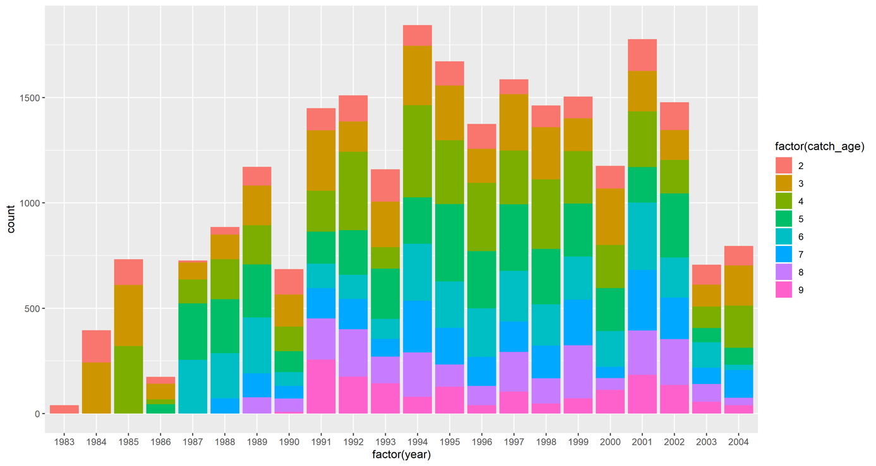

Figure S8. Count of catches of each age in both areas.

### Assumption check

#### Specific growth

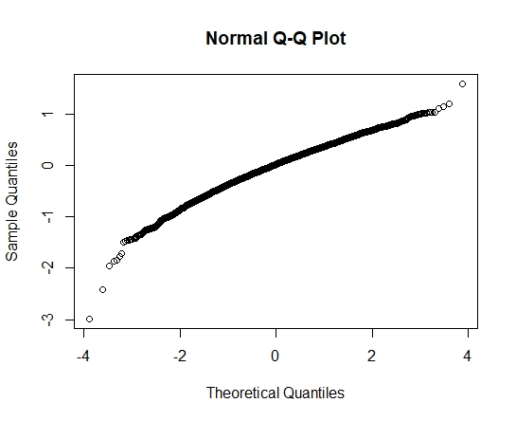

Figure S9. Theoretical and sample quantiles for the size-spectrum analysis

Figure S9 illustrates that there some limitation in the model used for predicting weight specific growth rates (SGR). The model assumes the relationship between and geometric mean weight to be linear on a log-log scale. Unfortunately, results from my analysis illustrate that the data does not perfectly follow a power law function.

The normal Q_Q plot suggest that the data, compared to a normal distribution, has slightly more data located at the extremes of the distribution and less in the centre of the distribution (Figure S9).

#### Von Bertalanffy growth model

|  |  |
| --- | --- |
| A | B |
|  | |

Figure S10. A) Illustrates the predictions made by the original version of the VBGM on the x-axis and the accuracy of the prediction on the y-axis. The distance from the line at 0 is how bad the prediction was for that value, where positive values for the residual (on the y-axis) mean the prediction was too low, and negative values mean the prediction was too high; 0 means the guess was exactly correct. B) The assumption of normality is adequately met if the histogram is symmetric without overly long “tails.".

The residual plot shows a funnel-like shape from left-to-right, which suggests that the variability around the model is not constant with a slight increase in variability with increasing X. There are also a lot of points quite far from 0, especially on the positive side indicating that the prediction was too low. The histogram suggests a slight right-skewed distribution of residuals.

An increase of the variability with increasing fitted values does however suggest that the data has a multiplicative error structure, i.e. the variability of length changes with increasing age. One way to deal whit this is to modify the Typical parametrisation of the VBGM from: , where *i* is a subscript index for individual fish and errors () are assumed to be normally distributed and additive, to , assuming multiplicative errors structure (). The logarithms of this equation gives: , where the error structure again is additive.

|  |  |
| --- | --- |
| A | B |
|  | |

Figure S11. A) Illustrates the predictions made by the modified version of the VBGM on the x-axis and the accuracy of the prediction on the y-axis. The distance from the line at 0 is how bad the prediction was for that value, where positive values for the residual (on the y-axis) mean the prediction was too low, and negative values mean the prediction was too high; 0 means the guess was exactly correct. B) The assumption of normality is adequately met if the histogram is symmetric without overly long “tails.".

The residual plot for the modified version of the VBGM shows that the variability around the model is constant and the errors are normally distributed with no outlying points (Figure S11., which suggest that the modified model adequately fits the data.

## Mortality

### Catch-curve analysis

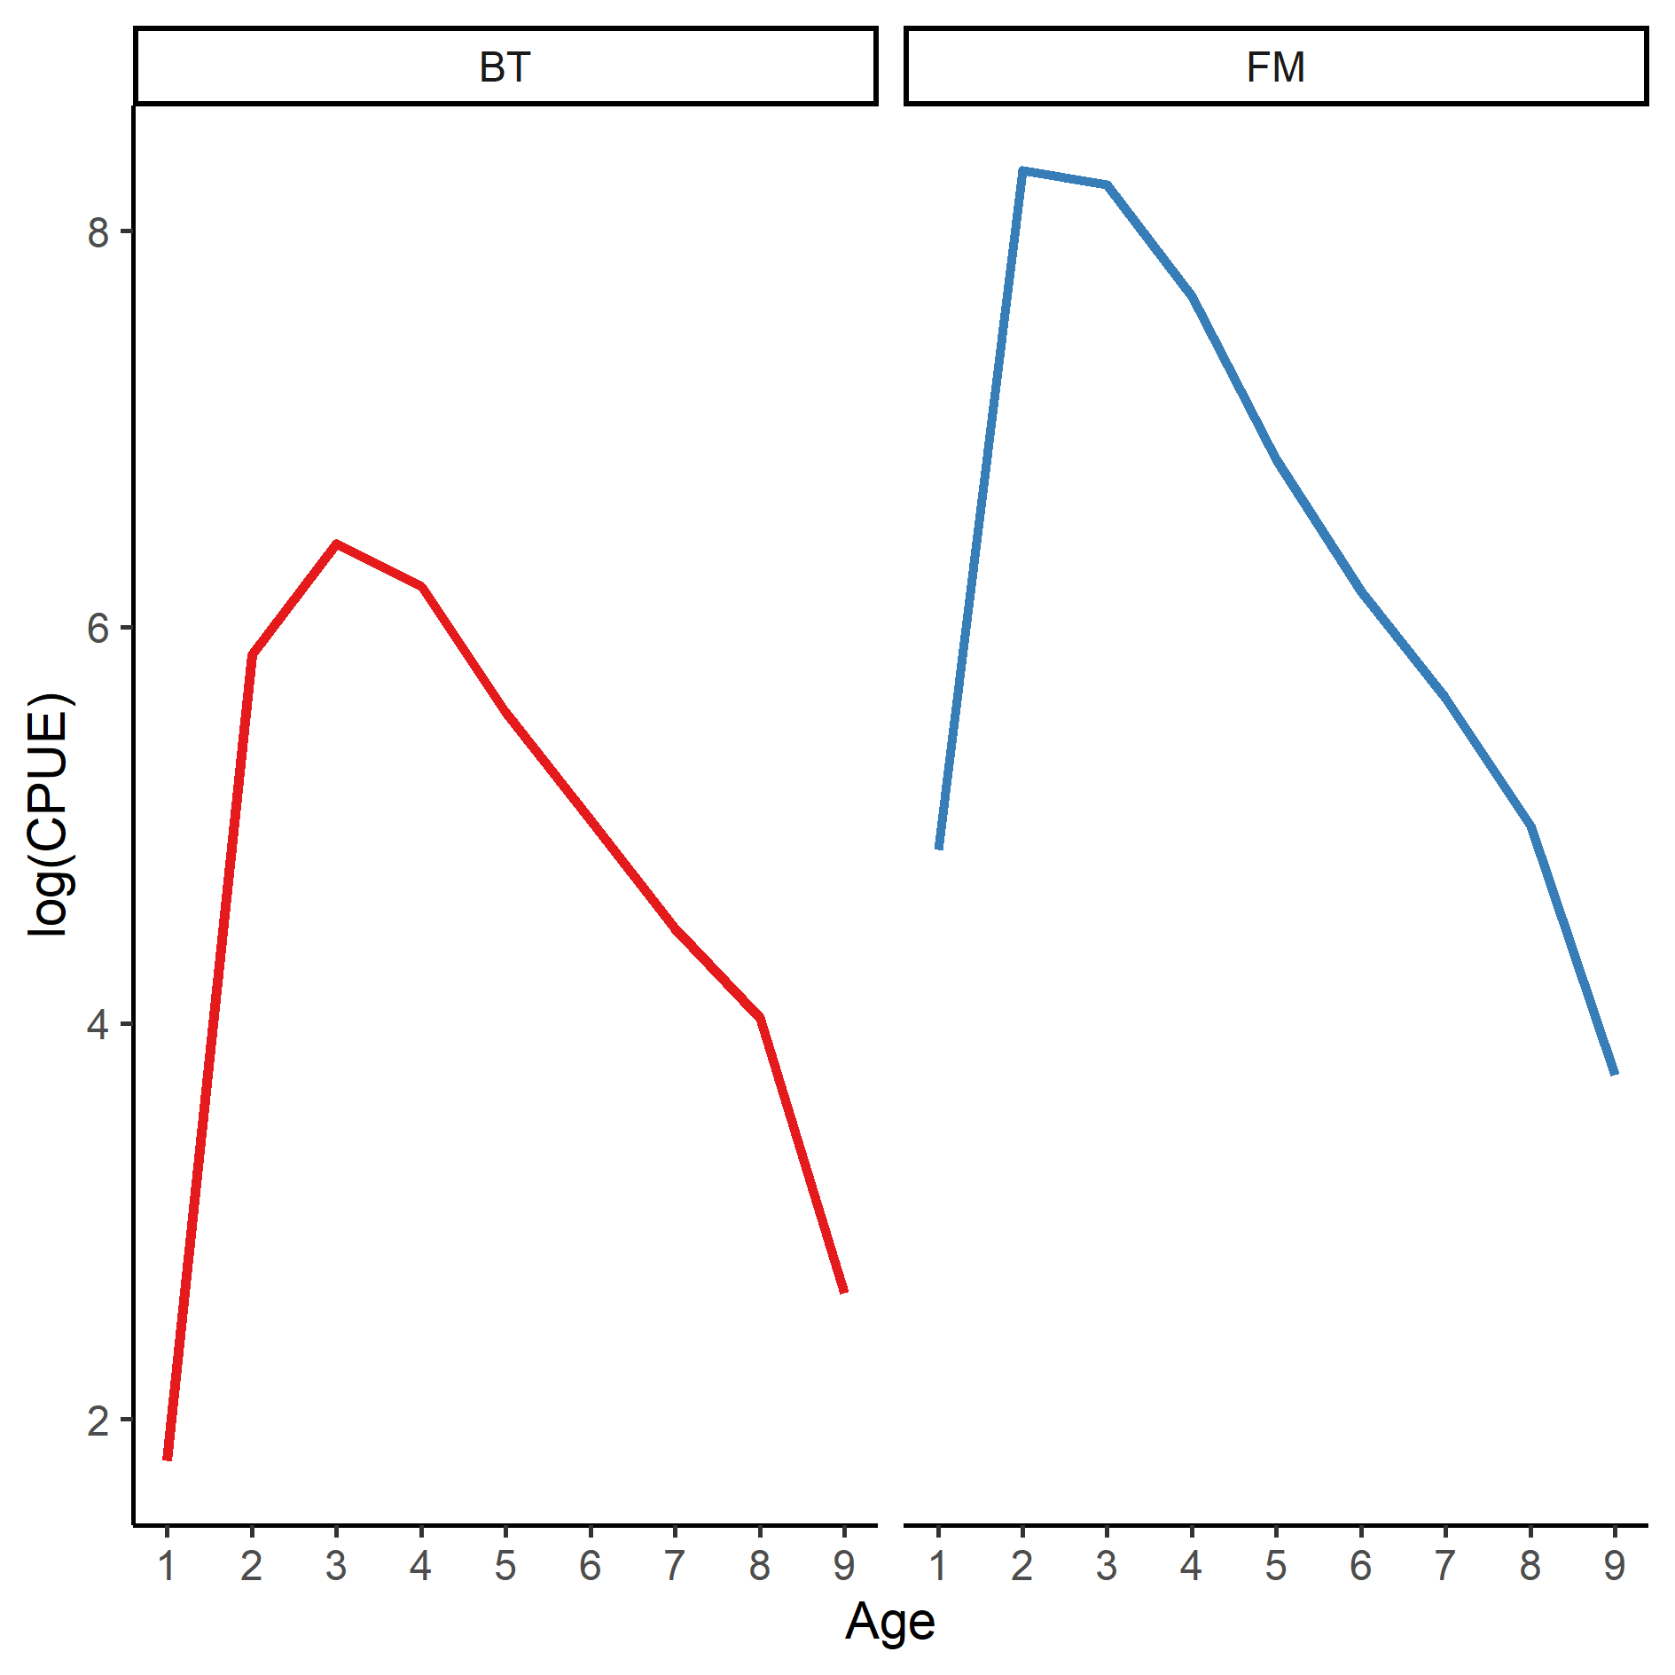

Figure S12. Catch curve with the natural log of CPUE versus age. Red line represents caches in the heated Biotest Lake and blue line represent catches from the normal temperate reference area.

Figure S12 visualizes the catch curve (CPUE for each age) for the two investigated populations. The increasing left part of the curve represent age classes of fish not fully vulnerable to the fishing gear. These catches are not useful for estimating the mortality rate and were removed for the rest of the analysis. The declining right part of the catch curve represents the regular decline of fully recruited fish, ≥ 3 years for the population in the heated area, and ≥ 2 years for the population in the reference area. For catch curve estimates of mortality, it is suggested that the first age to be included in the analysis is the age where the peak catch occurred (Smith et al., 2012). For catch curve estimates of mortality, it is suggested that the first age to be included in the analysis is the age where the peak catch occurred (Smith et al., 2012), I will therefor use ages ≥3 years for the rest of the analysis.

### Weighted regression method

To estimate mortality (), I used a catch-curve regression, representing the sequential decline of observed abundance per age class, where the slope of the regression is . Further, in order to reduce the relative impact of older ages with fewer fish, Chapman and Robson (1960) proposed that the regression method should exclude all age-classes above the age where the catches fall below five individuals. Later, Maceina and Bettoli (1998) suggests that a weighted regression should be used to minimize the bias caused by age classes with few individuals. I choose to use both methods for estimates of , a basic linear regression (using all ages ≥3 years) with an interaction of area, and a regression for each area weighted by numbers of individuals in each age class to compare actual values of estimated mortality () between the two methods. Here I describe only the weighted regression.

The **weighted regression** includes the same ages as the basic regression method to first fit an unweighted regression per area. The natural log number of fish of each age class predicted by this model was then used to serve as weights to a second regression of the natural log of age specific caches. The methodology of Maceina and Bettoli (1998) were implemented in R using the FSA (Ogle et al., 2019) and FSAdata packages (Ogle, 2019). This is illustrated here:

>thcc2 <-catchCurve (ct~age, data=data, ages2use=2:6, use.weights= TRUE)

> summary(thcc2)

Estimate Std. Error t value Pr(>|t|)

Z 0.643 0.1417 4.536 0.02005

A 47.430 NA NA NA

> confint(thcc2)

95% LCI 95% UCI

Z 0.1919 1.094

A 17.4634 66.516

Weighted catch-curve regression method generated exactly the same values as basic, indicating that the catch curves were not affected by potentially fewer individuals at older ages.

Table S3. Results from the weighted catch-curve analysis of Z

|  |  |  |  |
| --- | --- | --- | --- |
|  | **Weighted** |  |  |
| Warm | 0.81 |  | 0.69 – 0.92 |
| Normal | 0.64 |  | 0.61 – 0.68 |

## Size-structure

### Standardize length groups

The size-structure was analysed using length-frequency data of perch sampled with survey-gillnets during 1983 – 2003 in the heated Biotest lake and in the reference area. Fish were classified into 2,5 cm length groups during 1987 – 2001 (length group standard 2), and into 1 cm length groups during 2001 – 2003 (length group standard 3) (Figure S13). To enable comparable data, I converted the "finest" to the "coarsest" length group standard, i.e. 1 cm interval were converted into 2.5 cm interval.

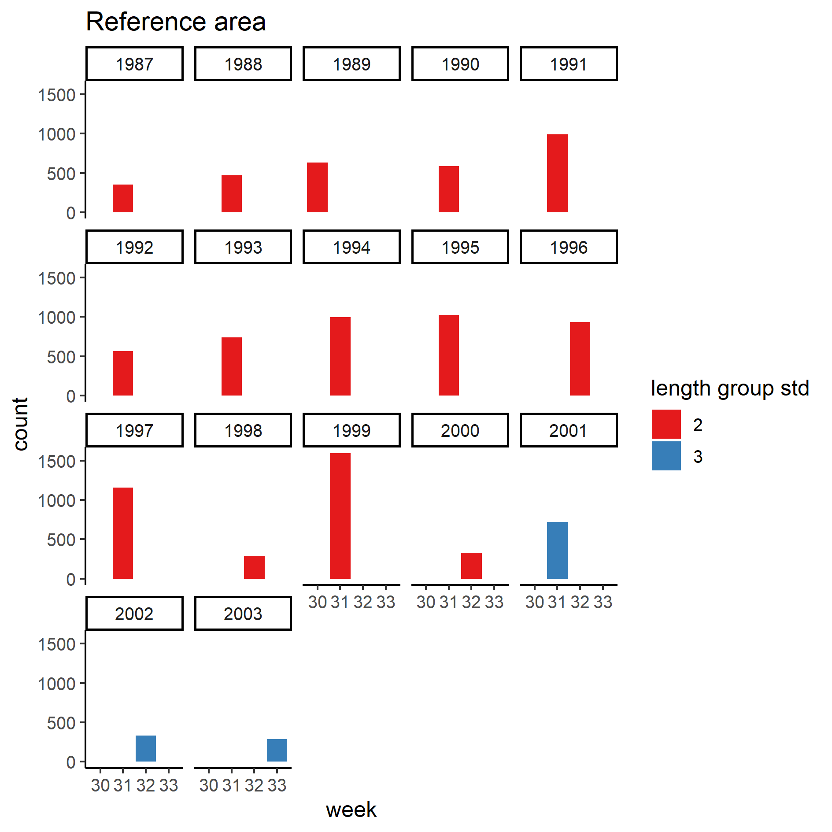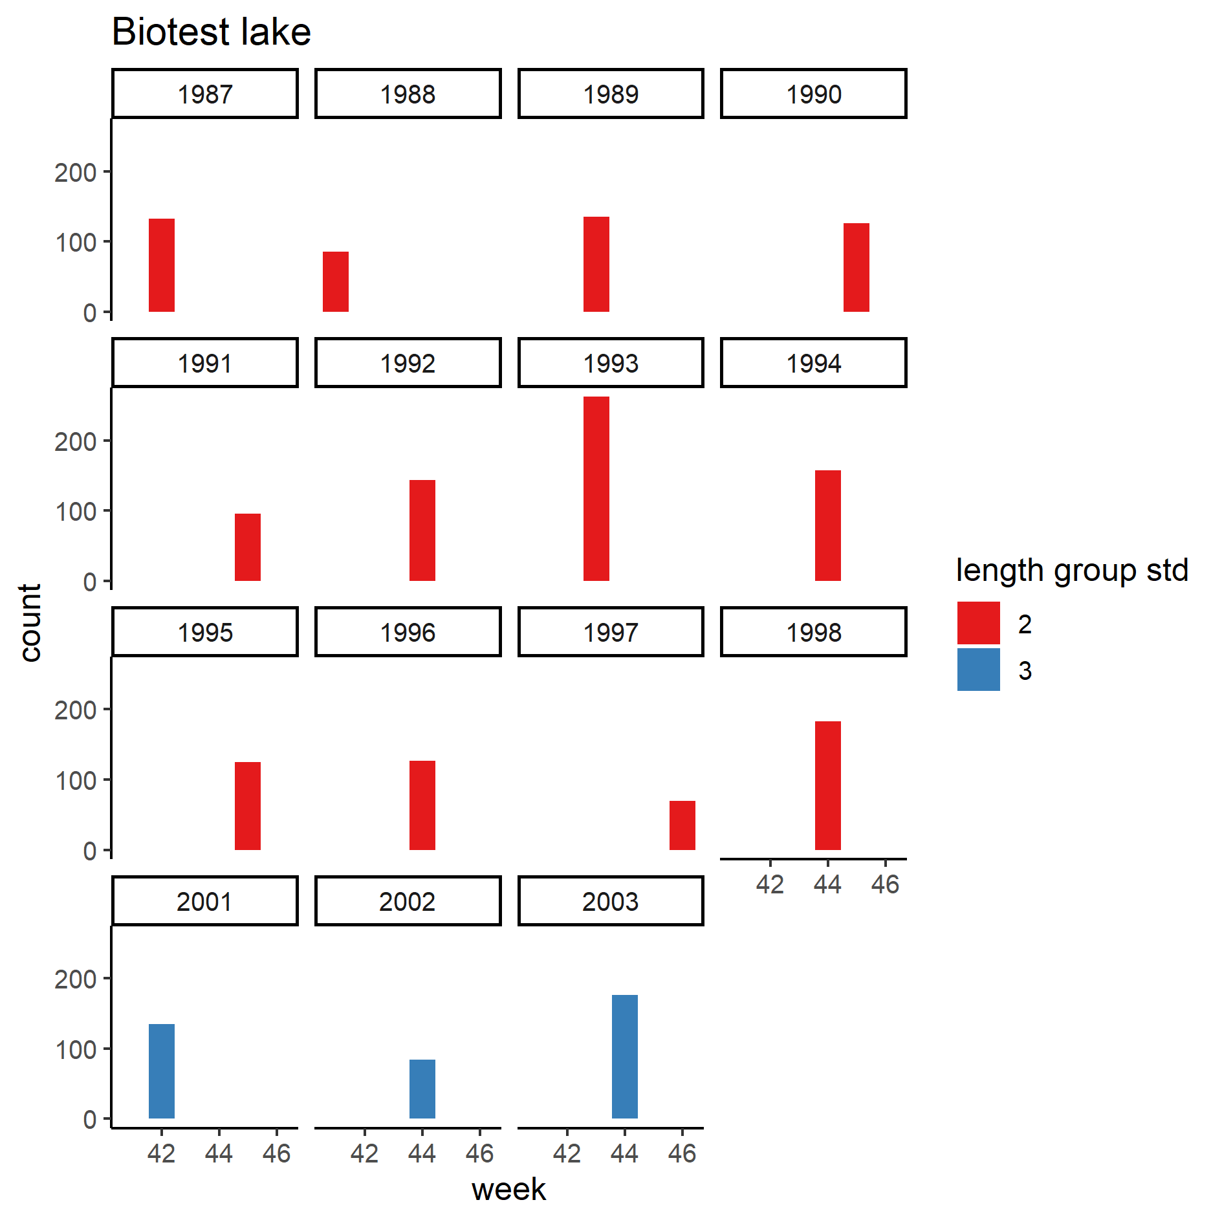

Figure S13. Length group standard used over the study period in the Biotest lake and the reference area.

The code in standard 2 refers to the integer nearest the middle of each interval. Thus, code 1 represents an interval of 0 - 2.5, code 4 an interval of 2.6 - 5, code 6 an interval between 5.1 - 7.5 etc. Code 2, 3, 4, 5 etc. are not included. The code in standard 3 refers to the end length for each interval, e.g. if the interval is 3.1 - 4, the code is 4. The conversion was done by giving a new code to all individuals who had code 3. The new code was first based on the median length for the interval and the code system for standard 2. Thus, if individual X has code 12 (based on standard 3 which has a range between 11.1 - 12), with the median length = 11.55. According to standard 2, will and individual of length 11.55 get the code 11 (

Table S4).

Table S4. Conversion from standard 3 to standard 2.

|  |  |  |  |  |
| --- | --- | --- | --- | --- |
| **Code standard 3** | **Median length** | **Code standard 2** | **Interval** | |
| 11 | 10.55 | 11 | 10.1 – | 12.5 |
| 12 | 11.55 | 11 | 10.1 – | 12.5 |
| 13 | 12.55 | 11 | 10.1 – | 12.5 |
| 14 | 13.55 | 14 | 12.6 – | 15.0 |
| 15 | 14.55 | 14 | 12.6 – | 15.0 |

In order to get even length classes (with respect to the code) I gave a new code to these which represents the starting length in each interval. E.g. if the interval is 12.6 – 15 with the original code 14, the new code becomes 12.6 (Table S5). The first interval (0 - 2.5 cm) will, with this method, be given the code 0, which could be problematic, but since the smallest length classes will be filtered out, I do not consider this as a problem.

Table S5. Example of conversion from code in standard 2 to new code based on the starting length in each interval.

|  |  |  |  |
| --- | --- | --- | --- |
| **Code standard 2** | **Interval** | | **New code** |
| 11 | 10.1 – | 12.5 | **10.1** |
| 11 | 10.1 – | 12.5 | **10.1** |
| 11 | 10.1 – | 12.5 | **10.1** |
| 14 | 12.6 – | 15.0 | **12.6** |
| 14 | 12.6 – | 15.0 | **12.6** |
| 16 | 15.1 – | 17.5 | **15.1** |
| 16 | 15.1 – | 17.5 | **15.1** |
| 16 | 15.1 – | 17.5 | **15.1** |
| 19 | 17.6 – | 20.0 | **17.6** |

### Disturbances

All data from fishing events with disturbance on the fishing gear (e.g. seal damage, strong algal growth on the gears, clogging by drifting algae, boat traffic or other human inference) were removed (Figure S14, Figure S15). In 1999 and 2000 were all data from the Biotest Lake removed due to strong algal growth these years.

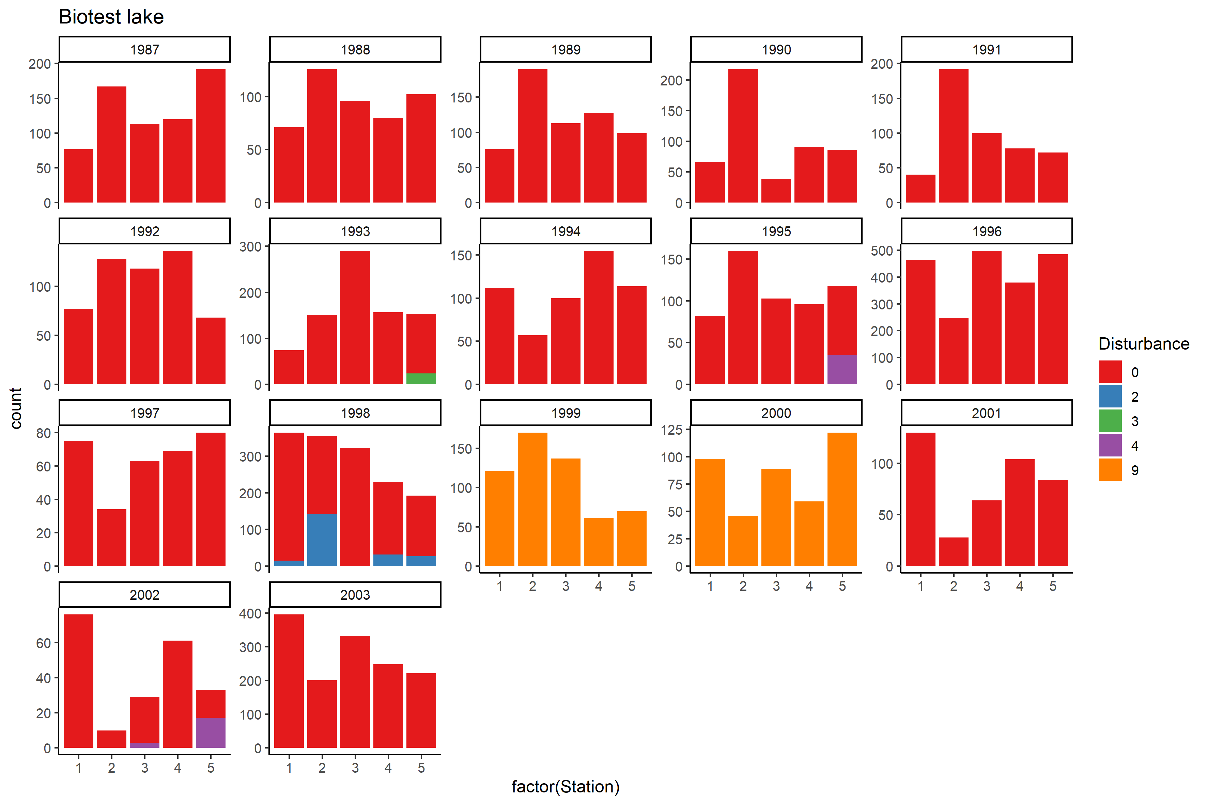

Figure S14. Overview of occasions of disturbance on the fishing gear in the Biotest lake. 0 = no disturbance, 2 = Seal damage, 3 = Strong algal growth on the gears, 4 = Clogging by drifting algae, 9 = Other reason. (Damage by boat traffic, other human interference etc.

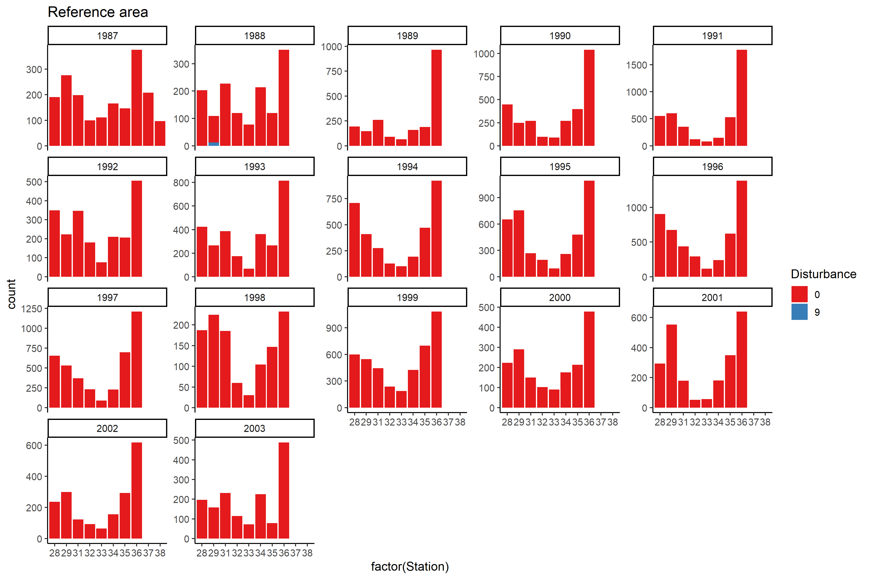

Figure S15. Overview of occasions of disturbance on the fishing gear in the reference area. 0 = no disturbance, 2 = Seal damage, 3 = Strong algal growth on the gears, 4 = Clogging by drifting algae, 9 = Other reason. (Damage by boat traffic, other human interference etc.

### Overfishing effect

Fishing have been conducted many days in a row to get an over fishing effect, and catches where expected to decline after a few days (Figure S16., Figure S17.). This effect was not preferable for my analysis. To avoid this, I used only the first day in the first week each year for my analyses.

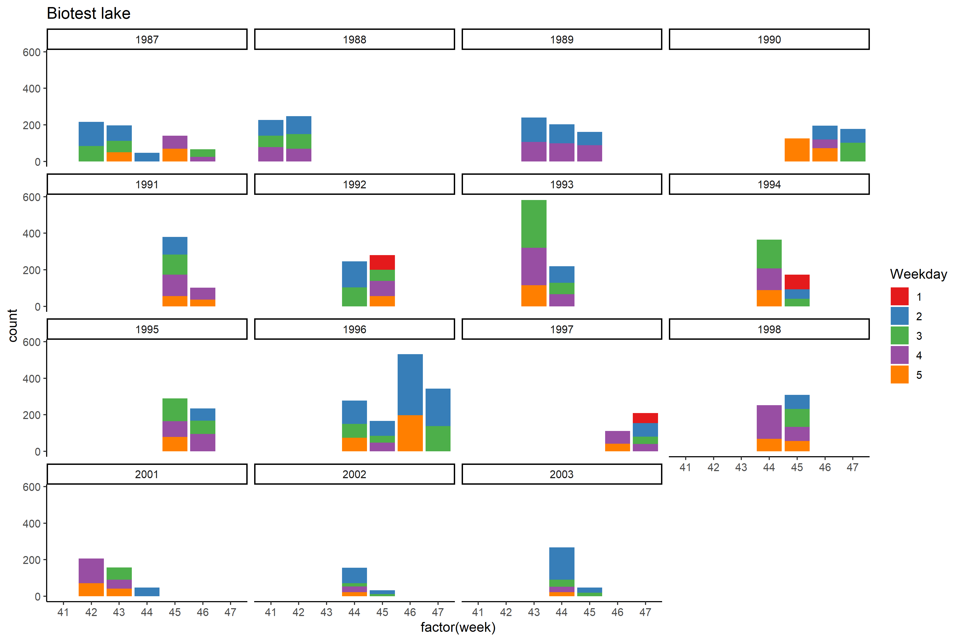

Figure S16. Overview of fishing occasions in the Biotest lake, with week number (time of year) on the x-axis and colours represents number of weekday (i.e. Monday = 1, Tuesday = 2, Wednesday = 3 etc.)

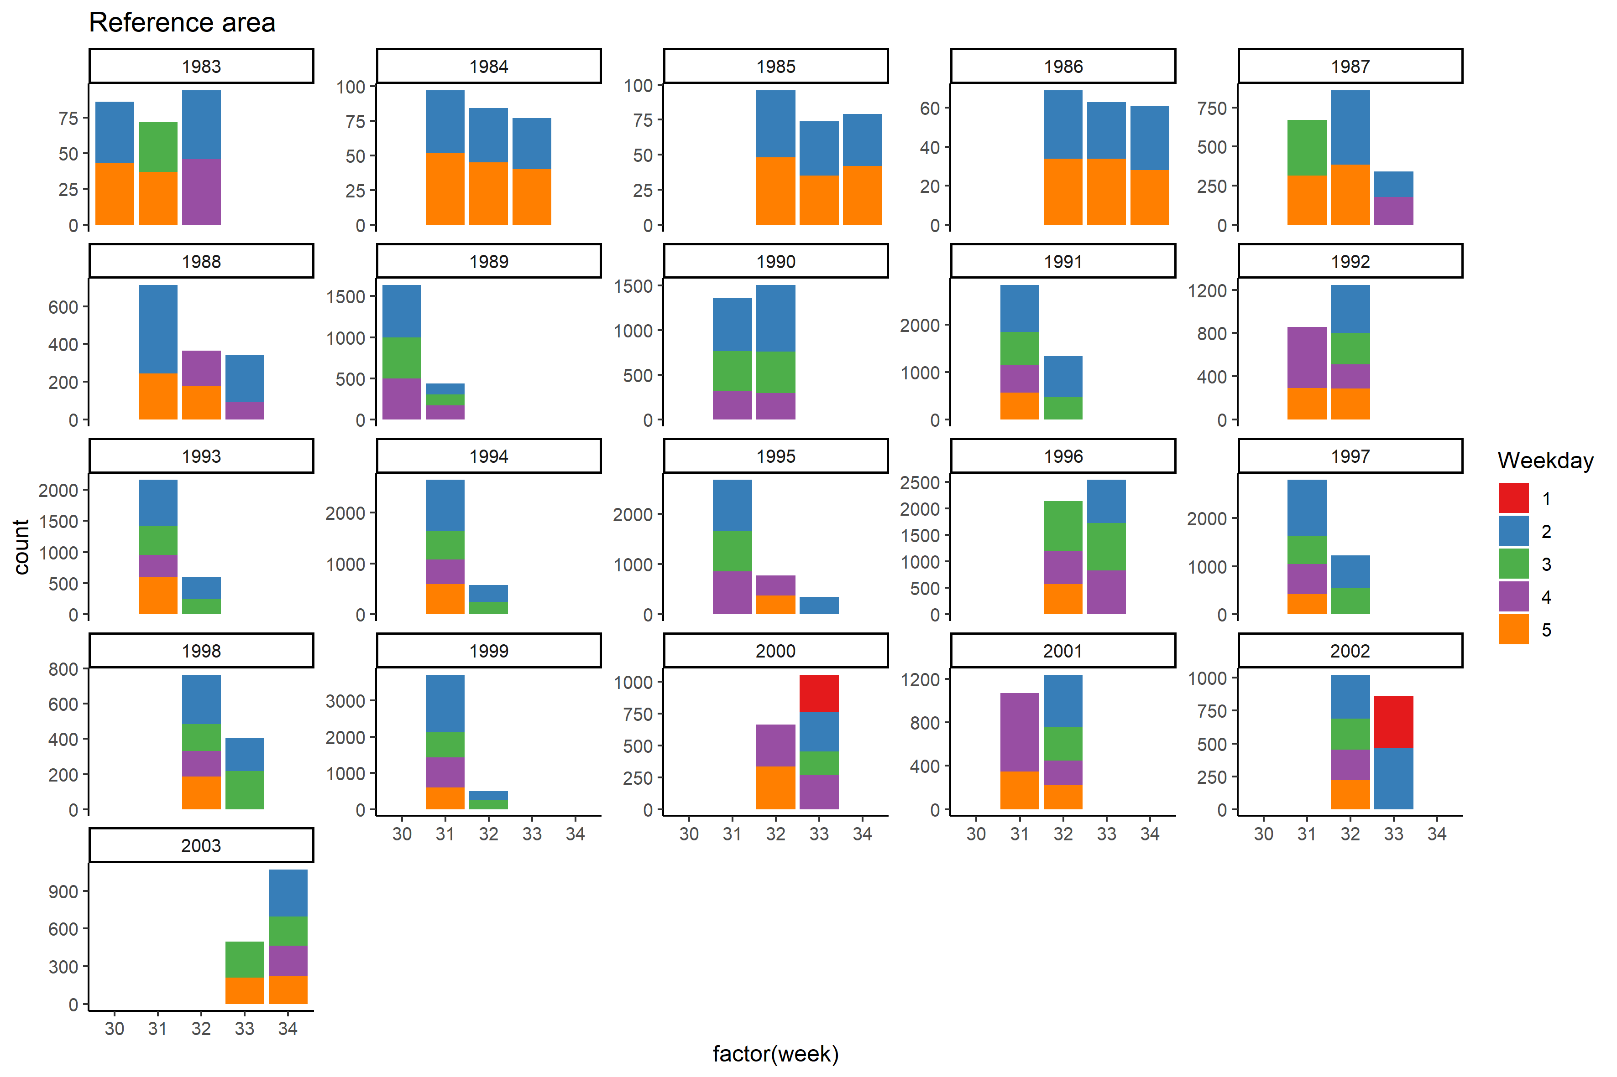

Figure S17. Overview of fishing occasions in the reference area, with week number (time of year) on the x-axis and colours represents number of weekday (i.e. Monday = 1, Tuesday = 2, Wednesday = 3 etc.)

### Sections and stations

Data from the Biotest lake is from net station number 1 – 5, and data from the reference area are from station 31 – 34, 28 – 29 and 35 – 38, see Figure S18, Figure S19 and map over study area (**Figure 1. Map over** study area with the fishing stations marked with numbers. Number 1-5 is located in the heated Biotest lake and number 31-34, 28-29 and 35-38 are stations in the reference area. . Figure S18 and Figure S19 shows that all stations are represented in the data during the study period, with few exceptions.

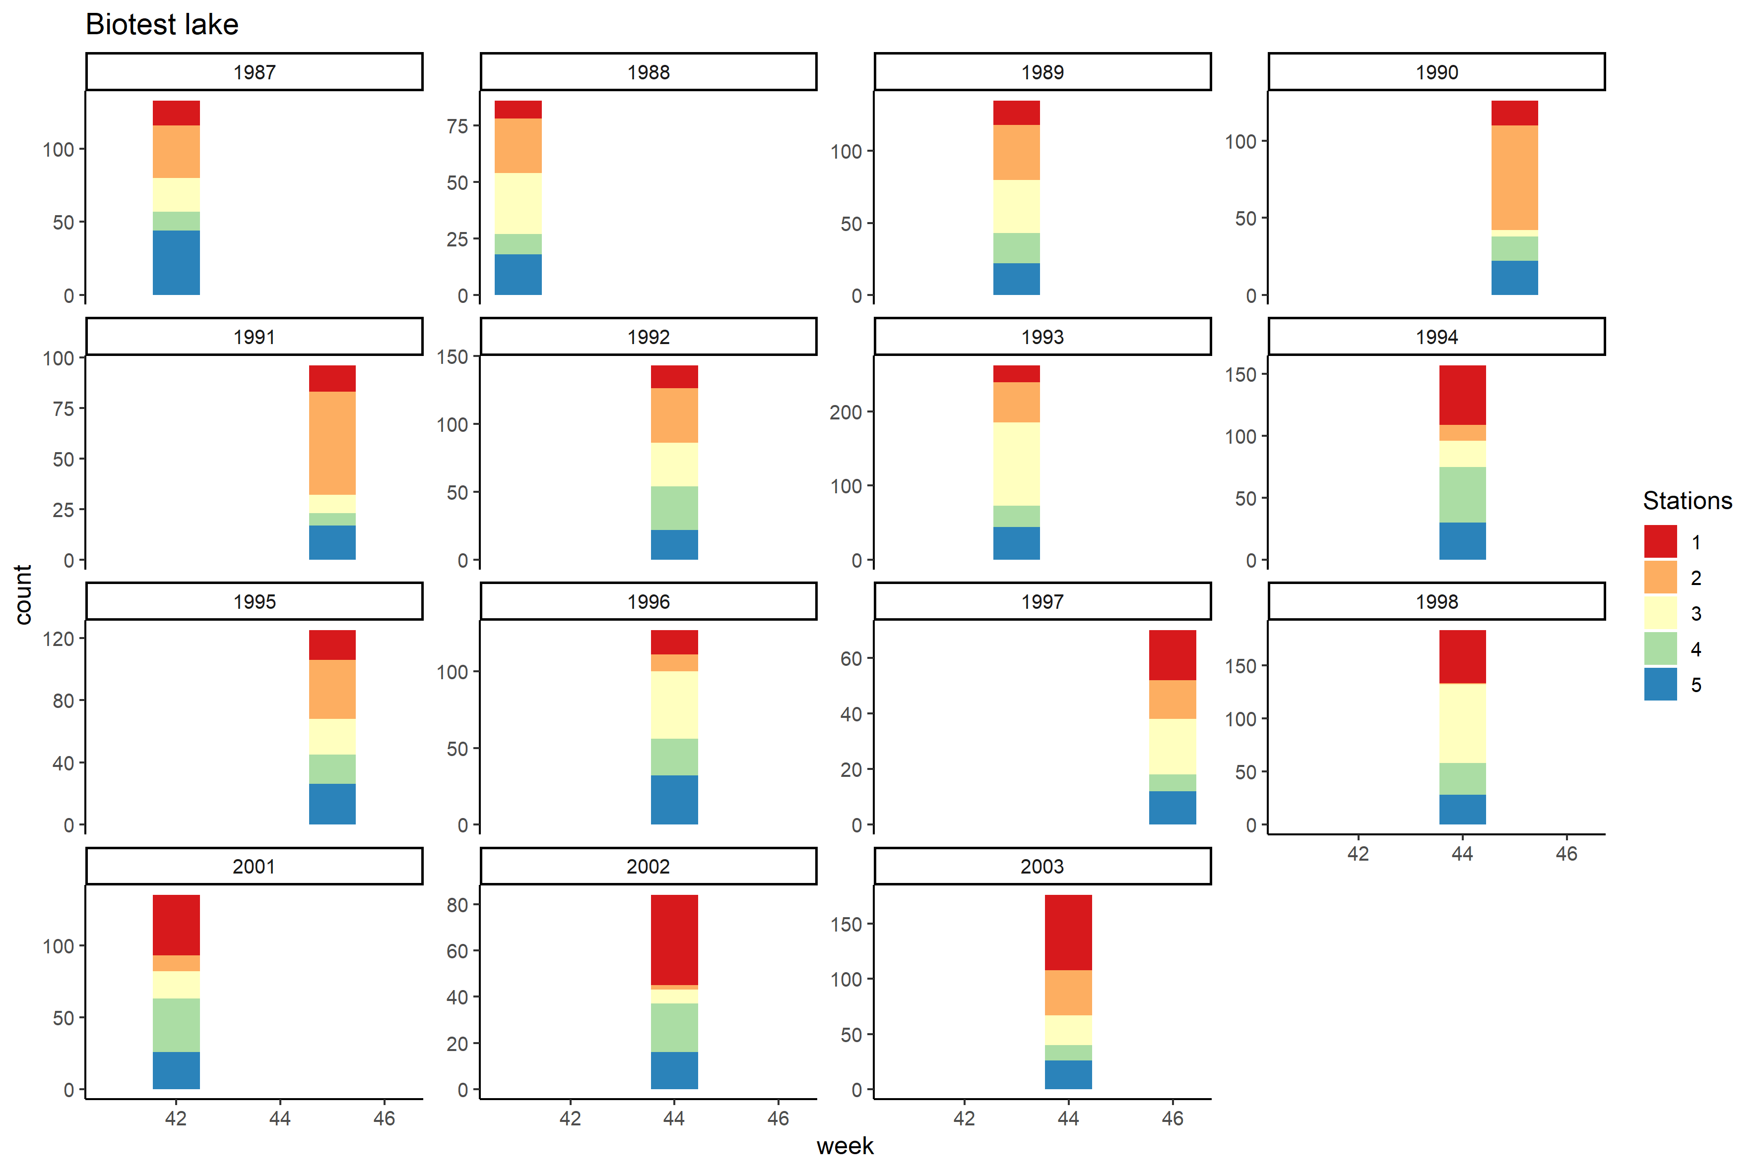

Figure S18. Fishing stations/location number of fishing nets in the Biotest lake. Station number in colours.

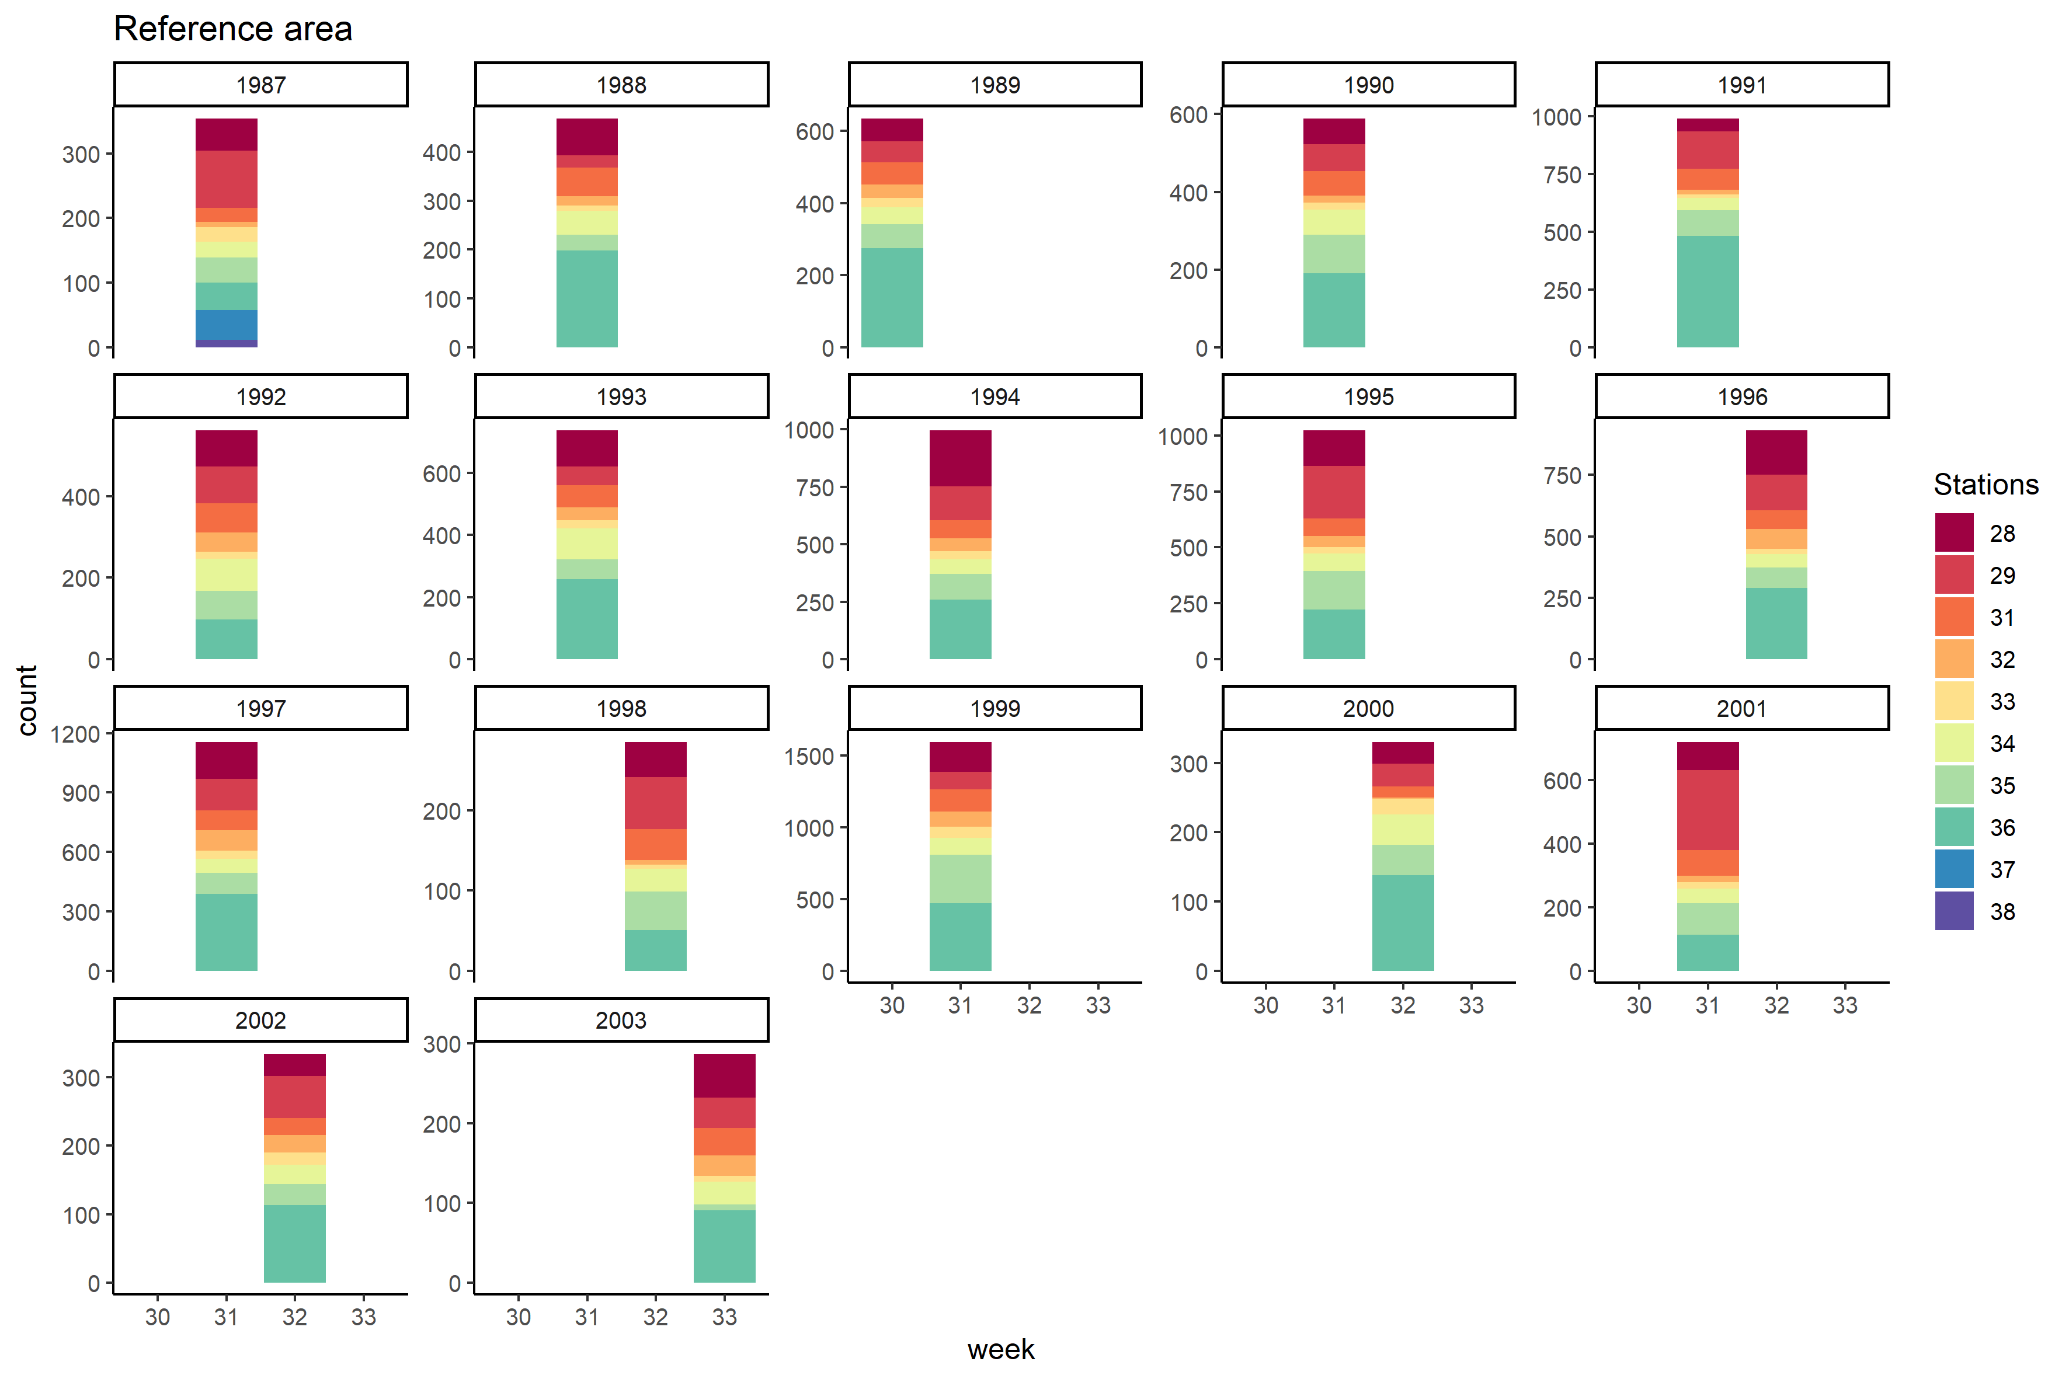

Figure S19. Fishing stations/location number of fishing nets in the reference area. Station number in colours.

### Smallest representative catch size

Perch > 12.5 cm have been shown to be caught efficiently in the used survey-gillnets (Sandstrom et al., 1995). Since catches which are not fully vulnerable to the fishing gear (<12.5 cm) is not use full for a size-spectrum analysis, these should not be included. However, my catch-curve analysis suggest that fish >17 cm is caught efficiently in the Biotest lake and fish >12 cm in the reference area (Figure S20). The actual size structure within a closed population is always such that the number of individuals per size decreases with size. Thus, only the decreasing part of the catches can be used to represent the true size structure of a population. Consequently, fish <17 cm were excluded from the size-spectrum analysis. Further, estimates of mean size was conducted using fish >12 cm since this most probably will represent the variation in sizes. The underlying cause of the difference in the smallest representative catch size is thought to be that the fish in the Biotest lake grow faster and the largest proportion of the first size caught has been able to grow past 12 cm (i.e. the fish that hatch in the spring / early summer will not be caught until the following year). The following year will this cohort be 1 ½ years larger than what they are in the reference area. Thus, there will be fewer 12 cm fish in the Biotest lake since these have grown past the mesh size that catches fish of 12 cm.

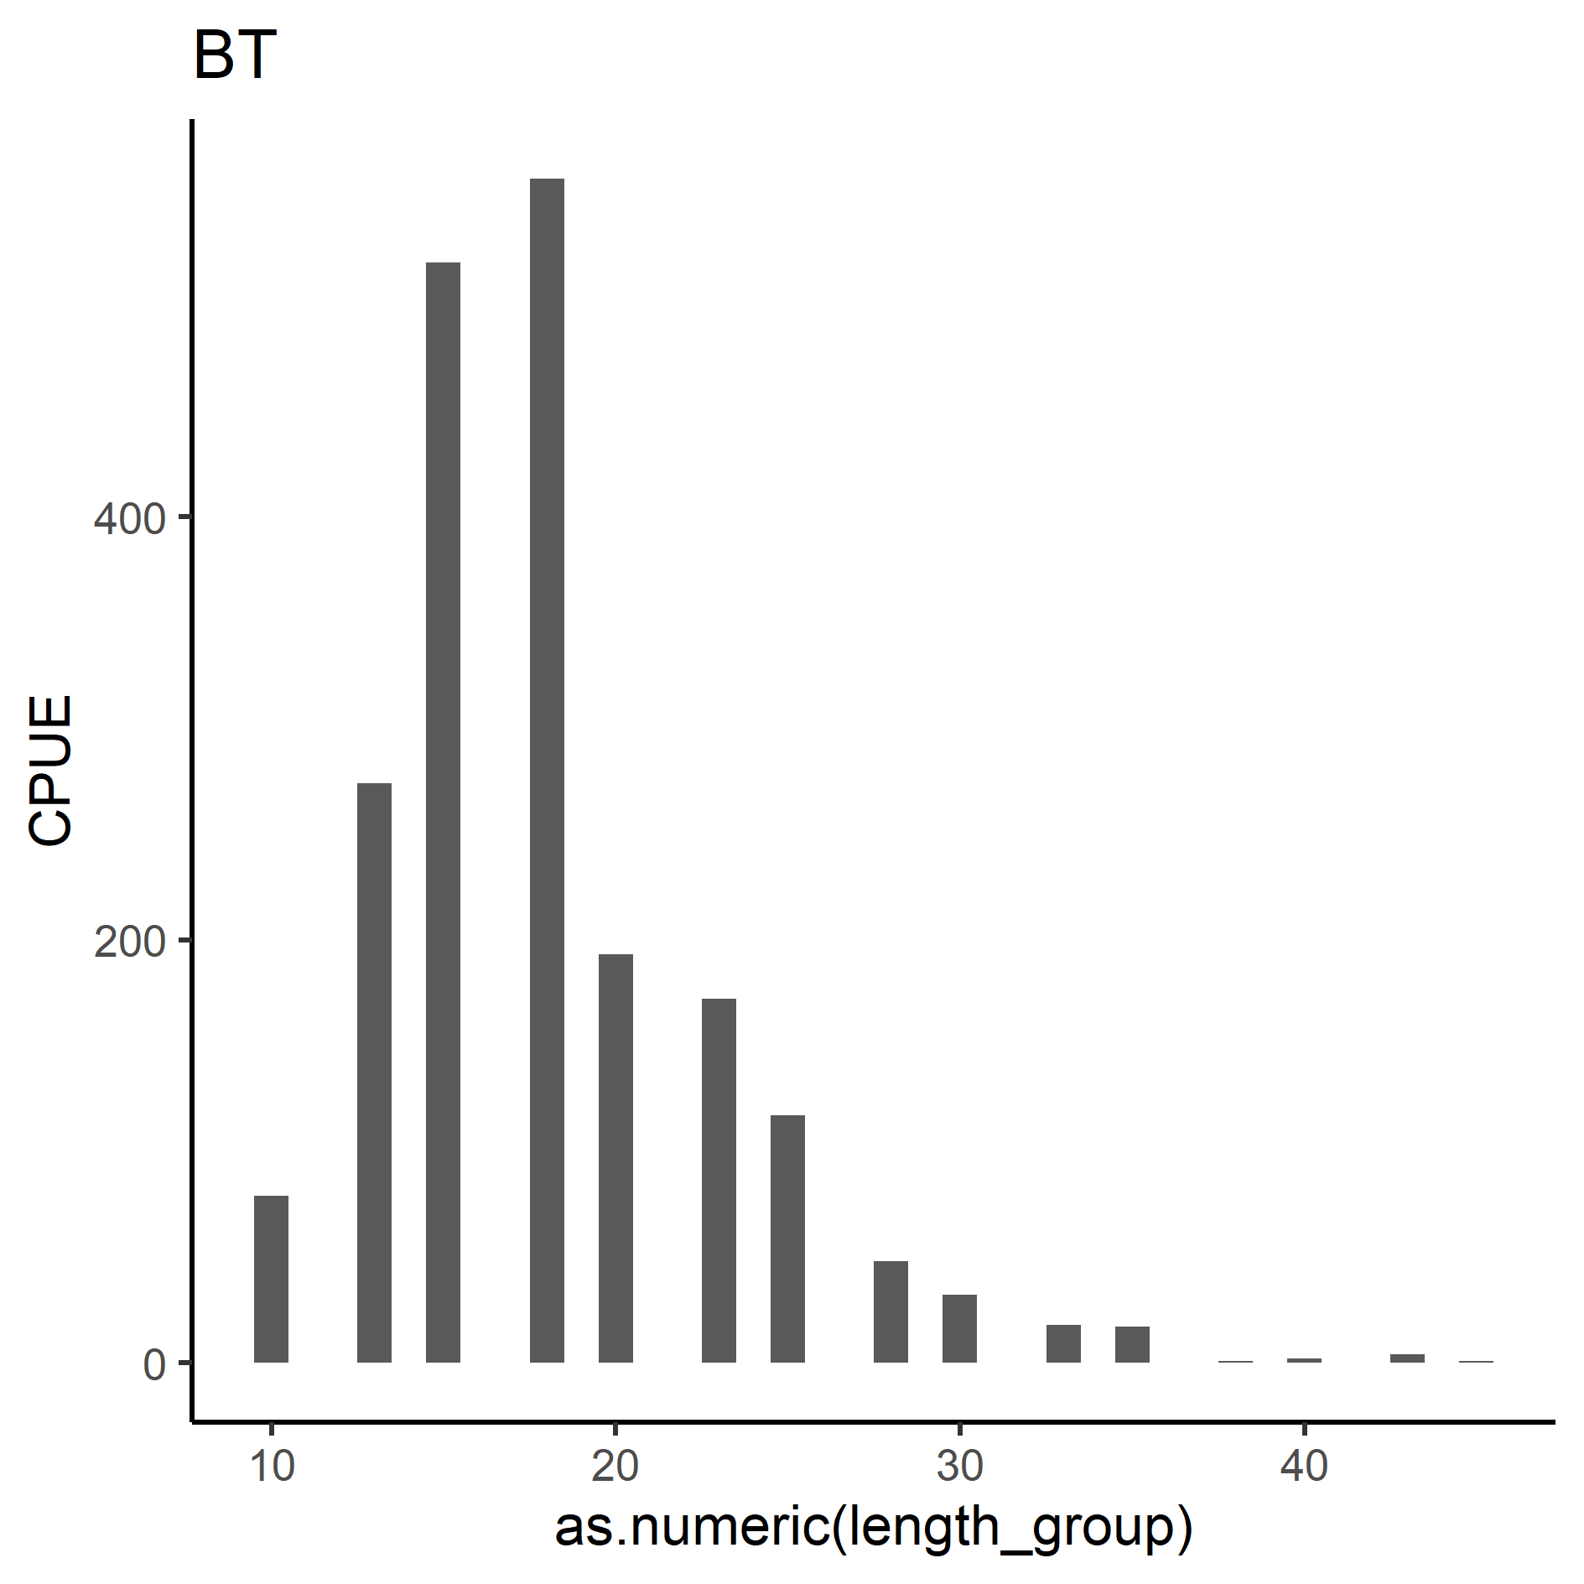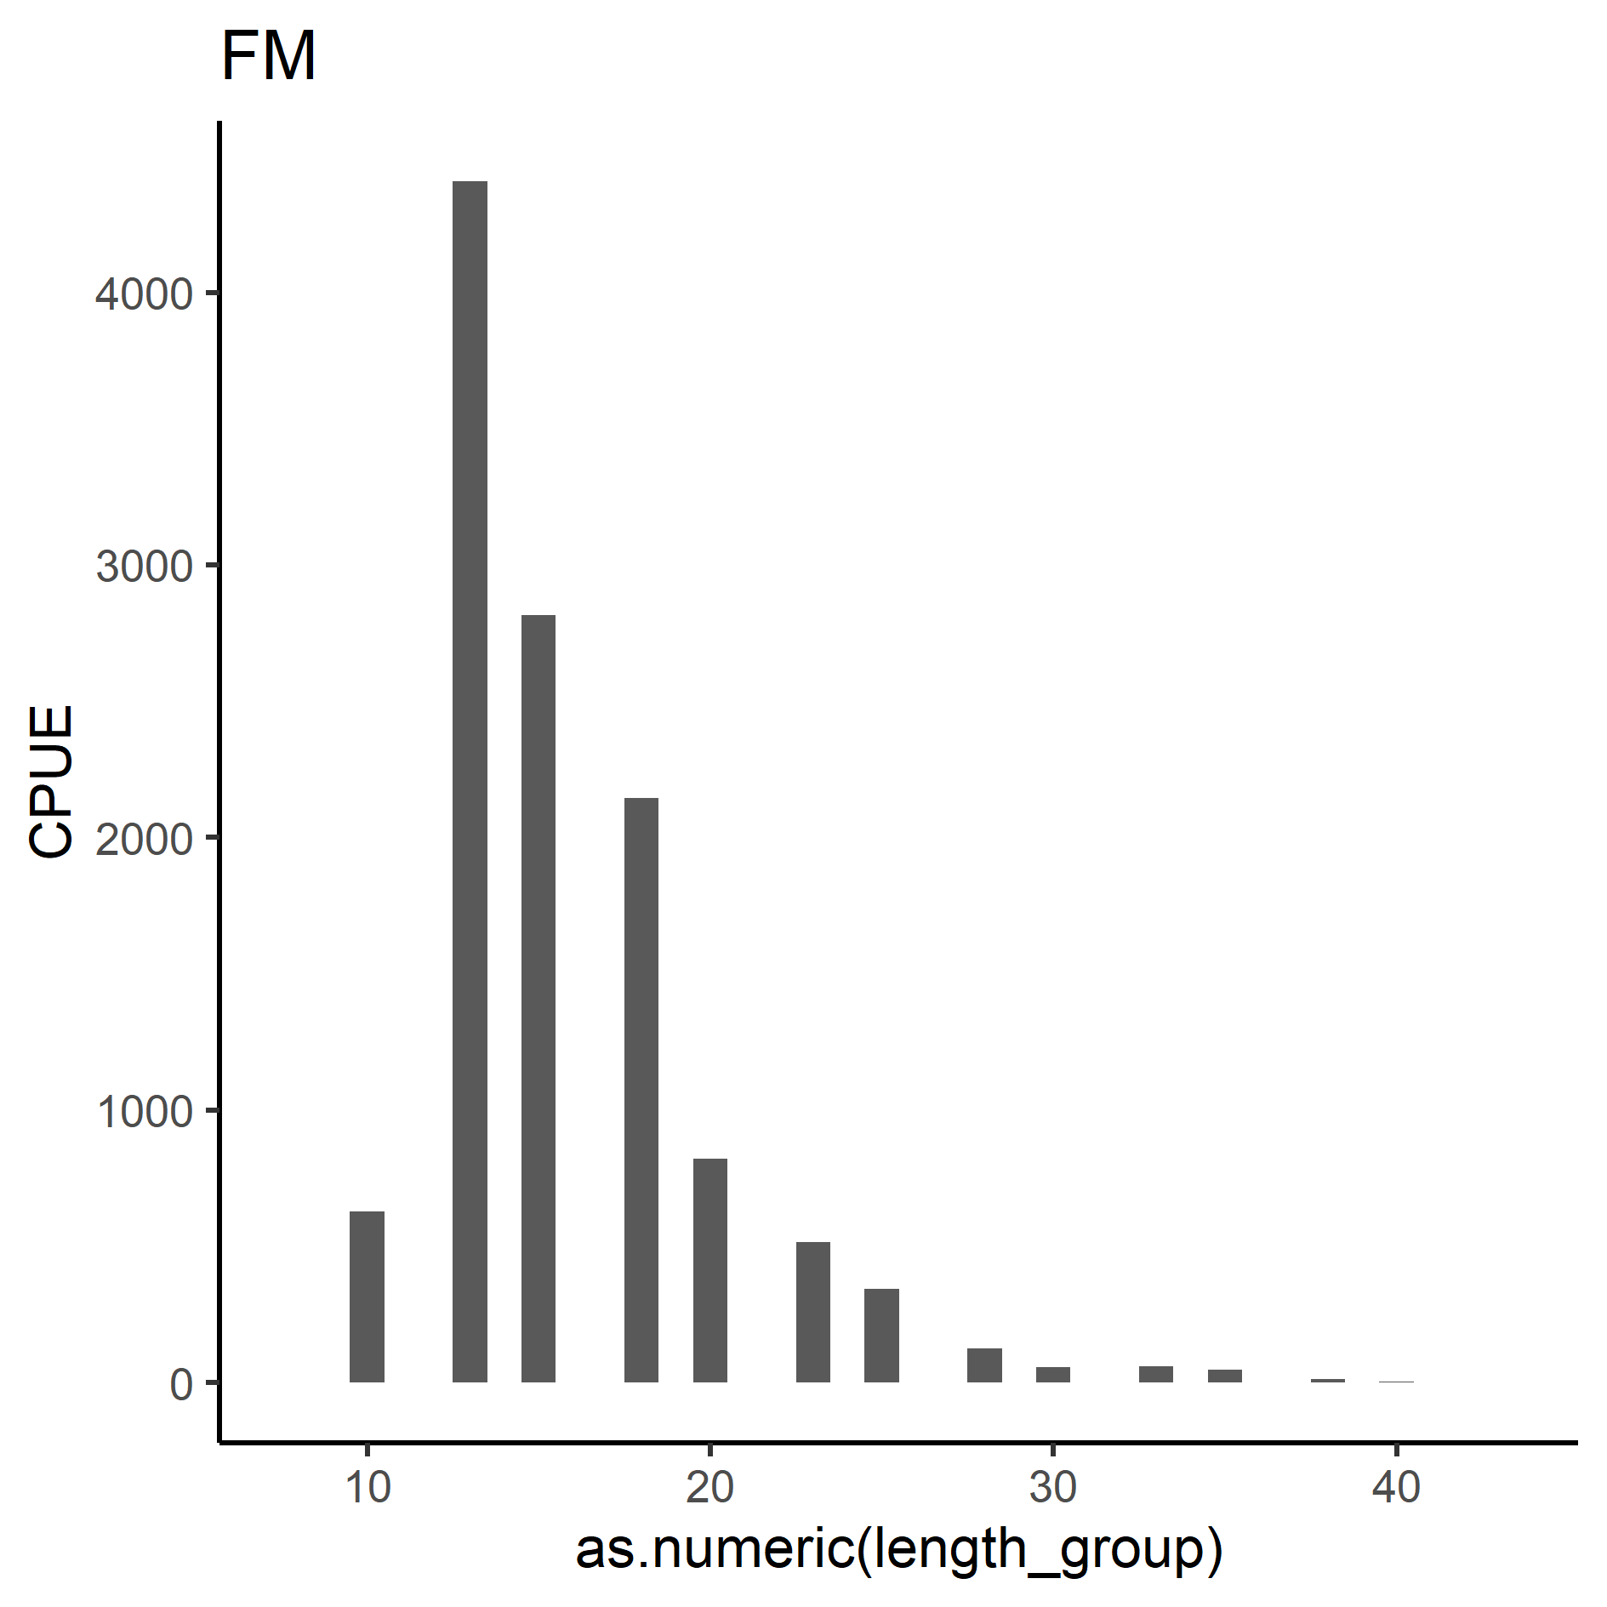

Figure S20. Catch-curve in CPUE for the heated Biotest lake, BT (left), and the reference area, FM (right).

### CPUE

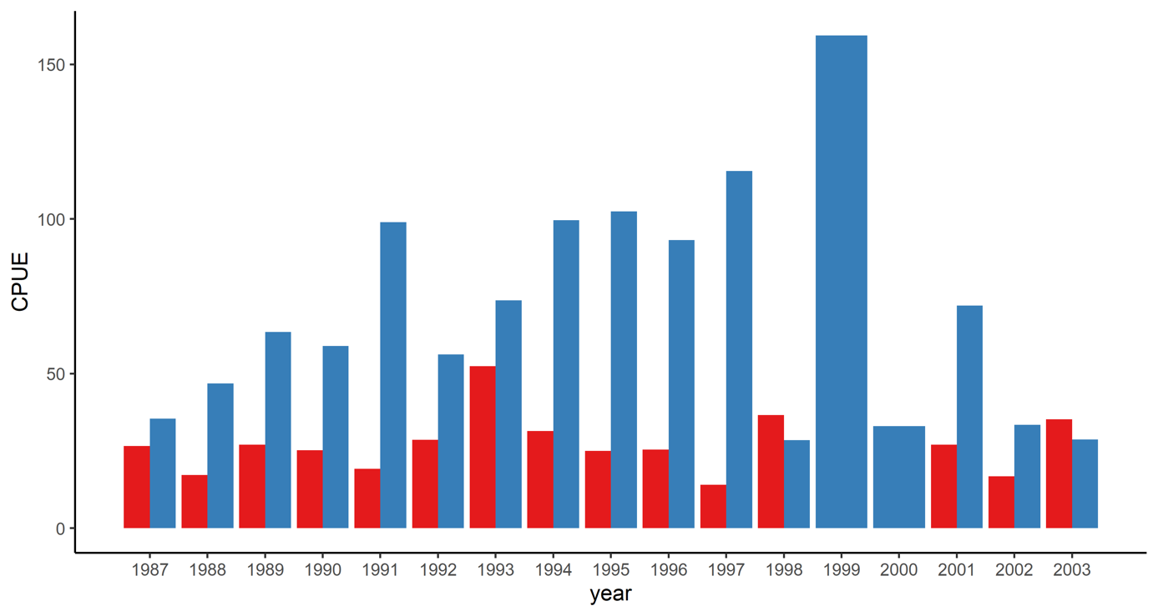

Figure S21. CPUE in the Biotest lake (red) and the reference area (blue) during the investigation period 1987-2003.

### Assumption check

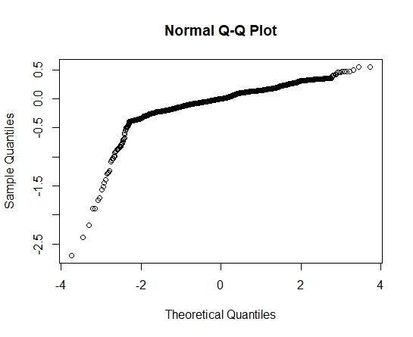

Figure S22. Theoretical and sample quantiles for the size-spectrum analysis.

Results from the size-spectra analysis suggest that the data does not perfectly follow a power law function. The normal Q_Q plot suggest a left skewed distribution where the points trend downwards meaning that the actual (sample) quantiles occur at lower values than the theoretical quantiles (Figure S22.).